GIT MINI PROJECT 1

Lab 1:

Creating ec2 instanc

*login to aws console

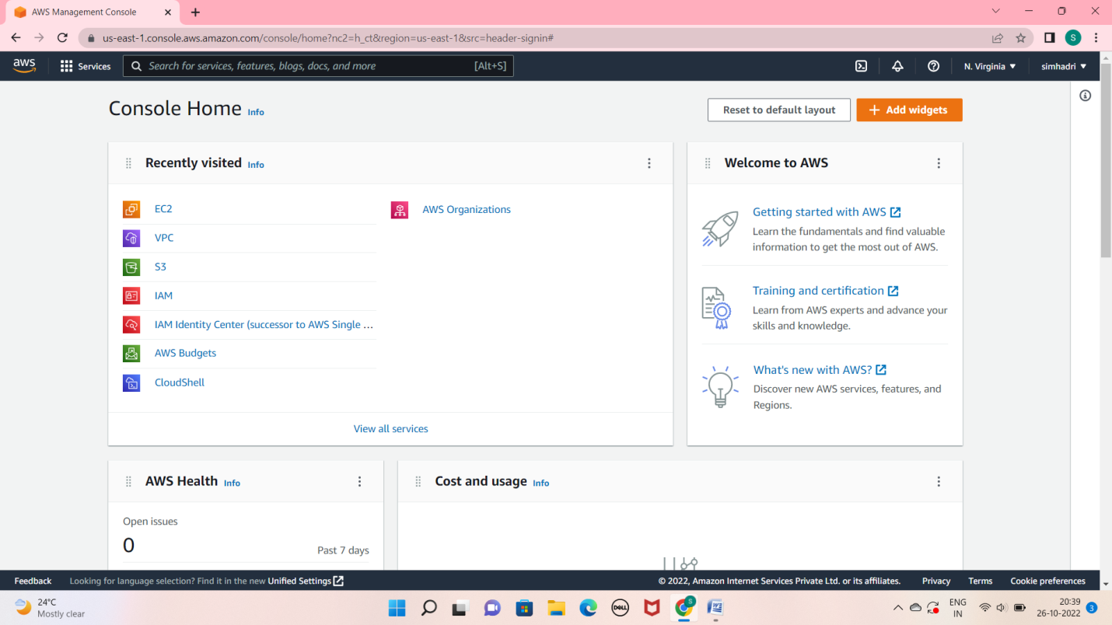

# *create a server with amazon linux 2 AMI

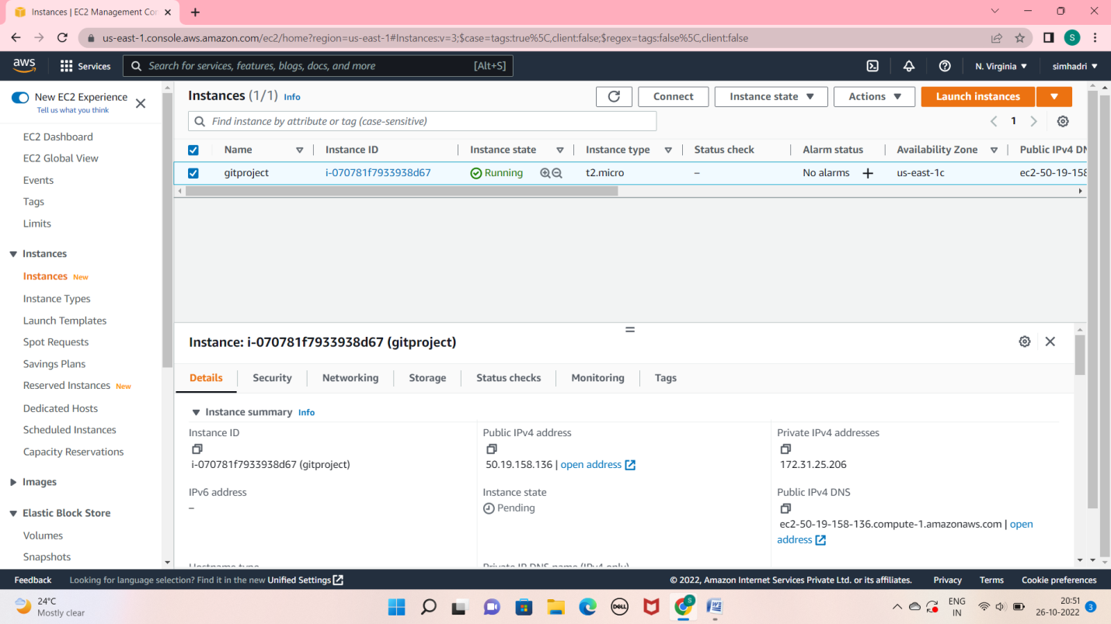

Now im connected git bash

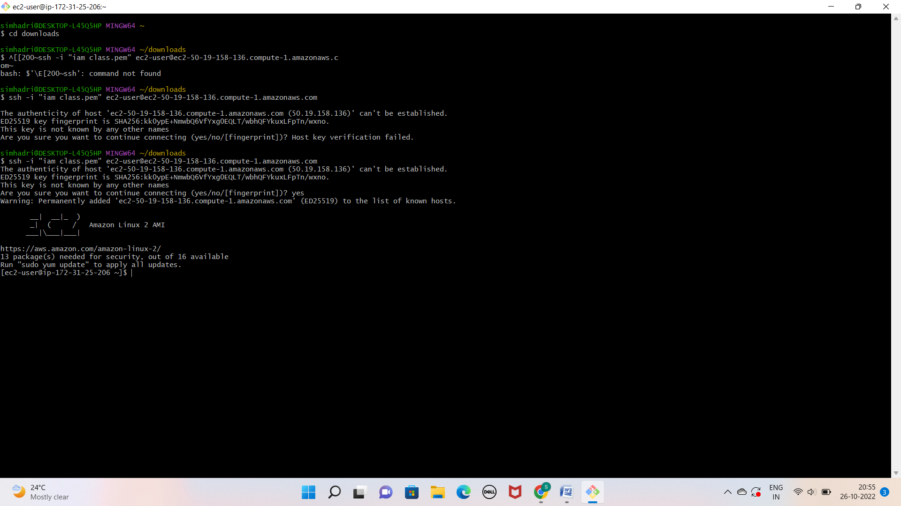

# Lab2: create repo in local machine

* Create a folder on my local machine

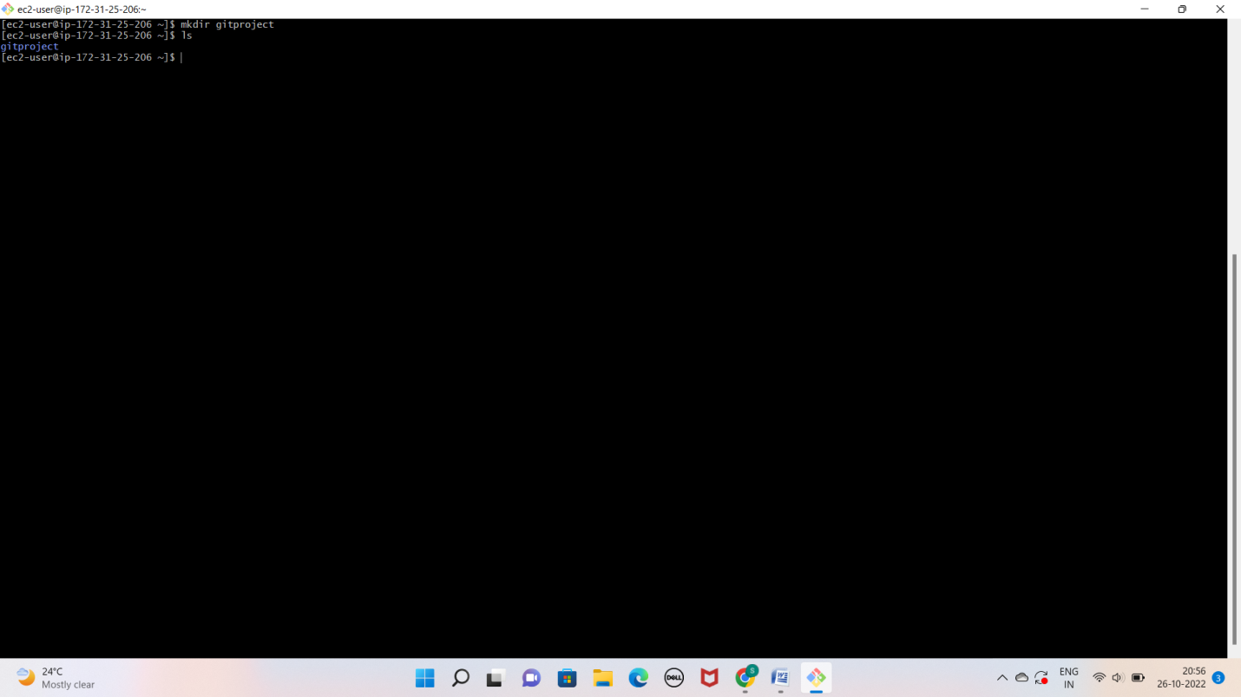

# *initialize this folder using git init command

a. git init[folder name]

b. go inside this folder and run git status command to check the status

# *initialize this folder using git init command

a. git init [folder name]

b. go inside this folder and run git status command to chechk the status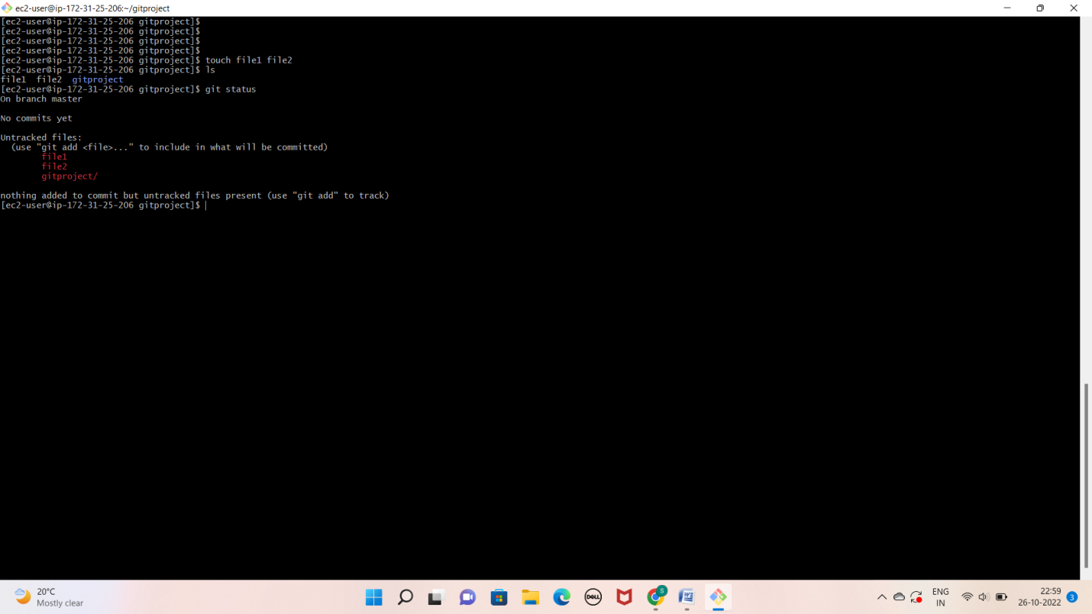

* create some empty files using touch command

a. touch test

b. again run git status to see the changes, you can notice that the files is avaialabe but not tracked by git

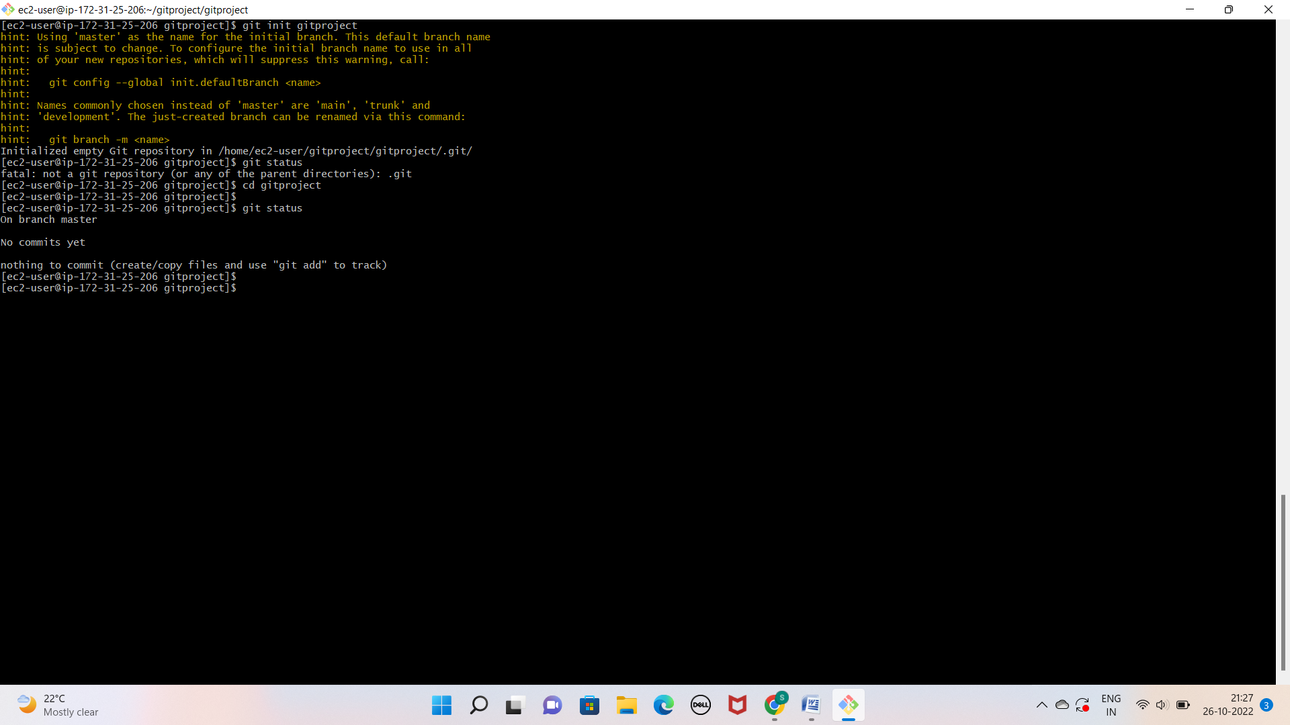

* Run git add to stage this change you check it using git status once again

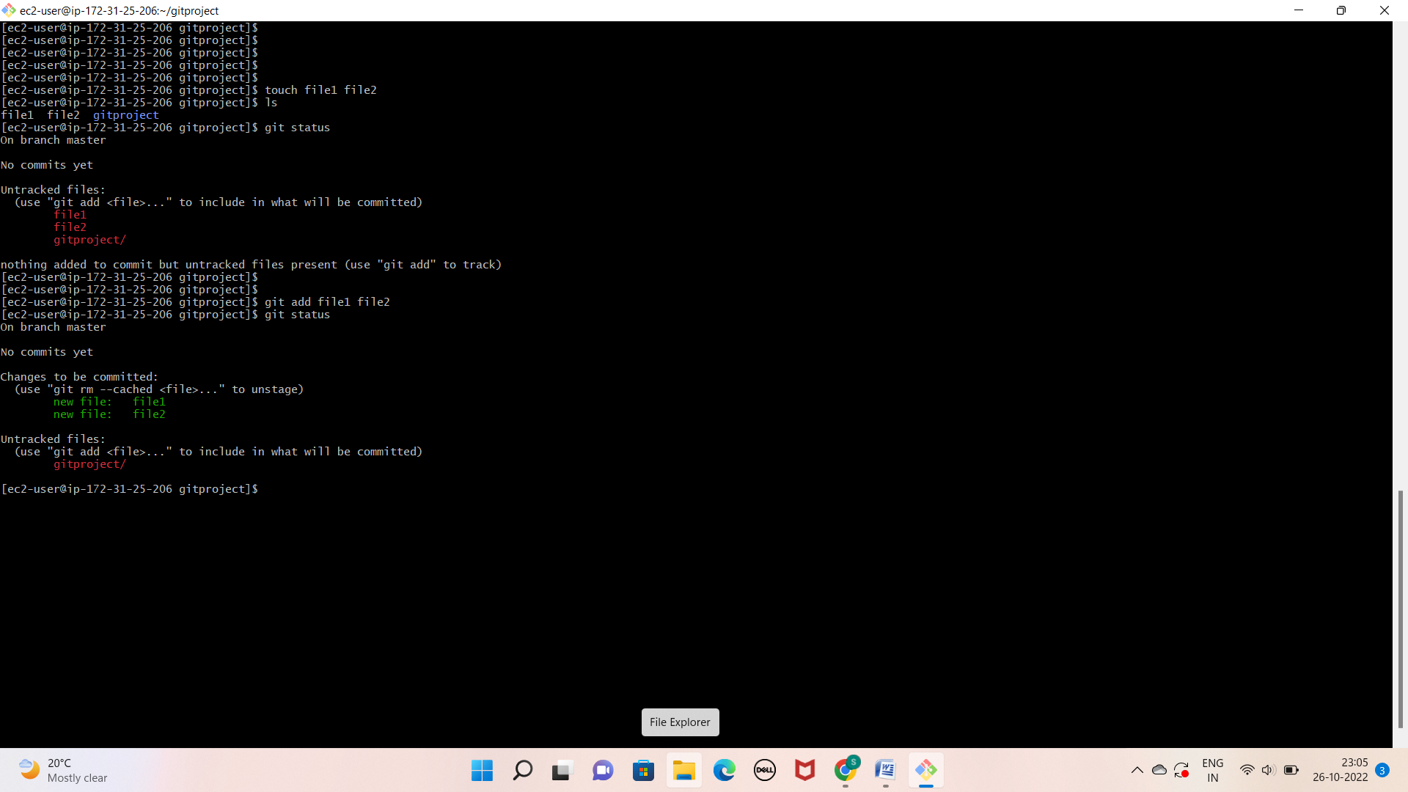

* Now commit our changes by running git commit –m “added test files”
* Run git status once again and it will show you that the working tree is clean

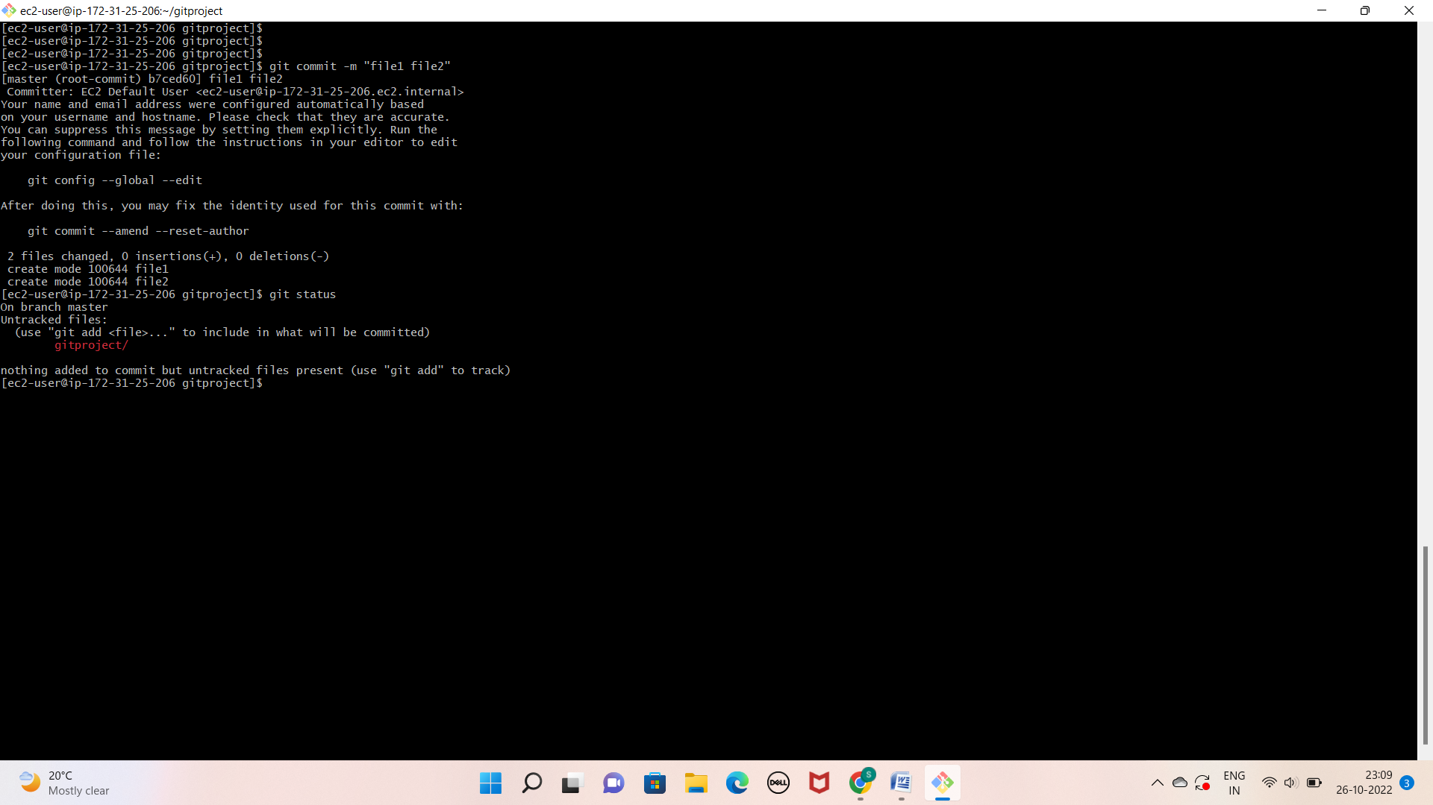

Lab3: creating repo in remote location _ github

* Now create a new repository by clicking on new button

1. provide repo name
2. whether it is a private or public repo [ recoomended by private]
3. initialize the repo by adding a README.md file.

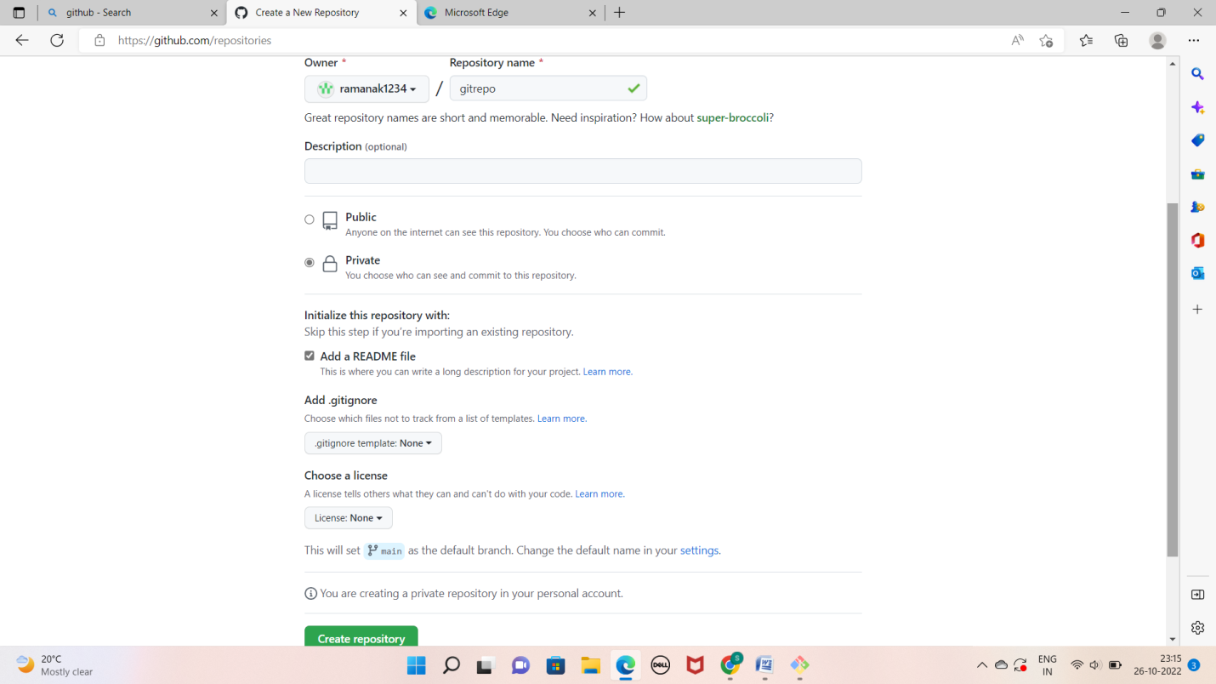

* click on ceate repo and done

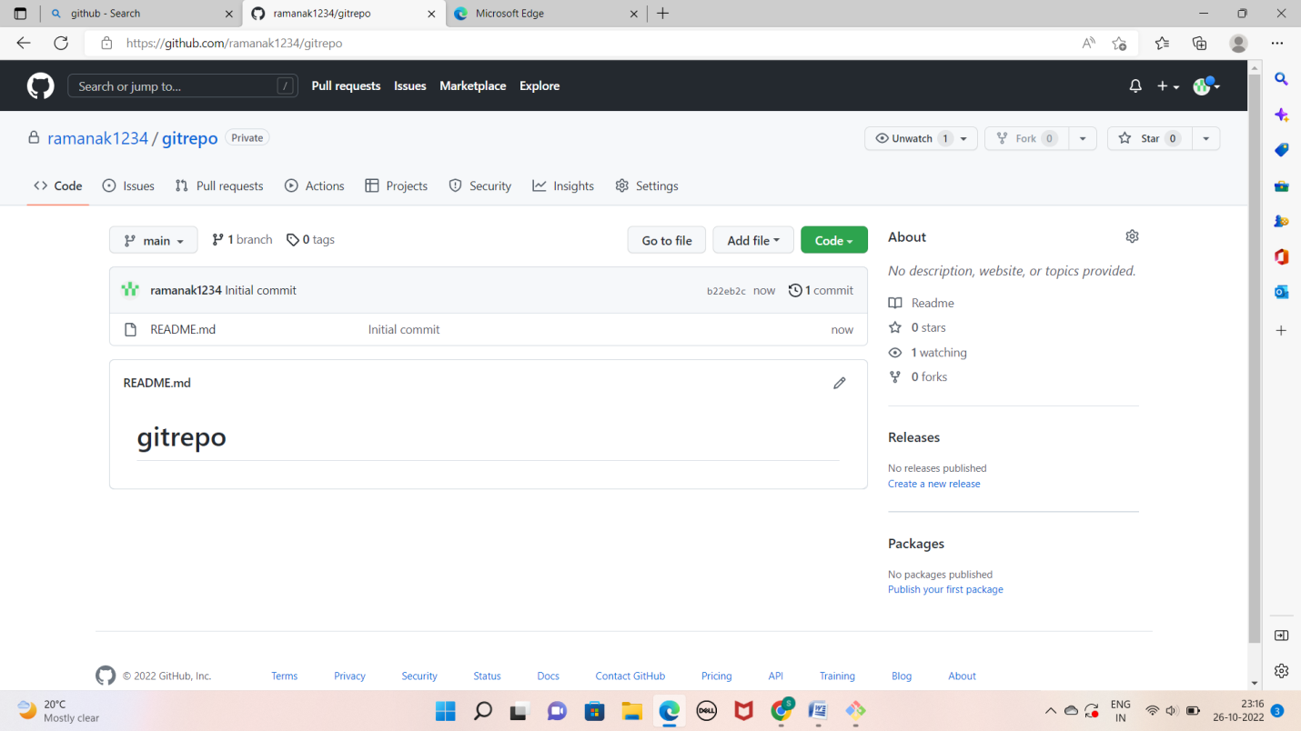

Lab4: working with remote repo

* pick the clone url of the repository from the github repo
* go to your local machine and clone this repo using git clone command

1. git clone
2. here you will get one error for password –based authentication depreciation
3. now, we need to create the personal access token to work with this repo
4. at the top right corner click on the user icon
5. go to settings c.developer settings
6. personal access token
7. click on generate token
8. provide a note
9. expiration date scope

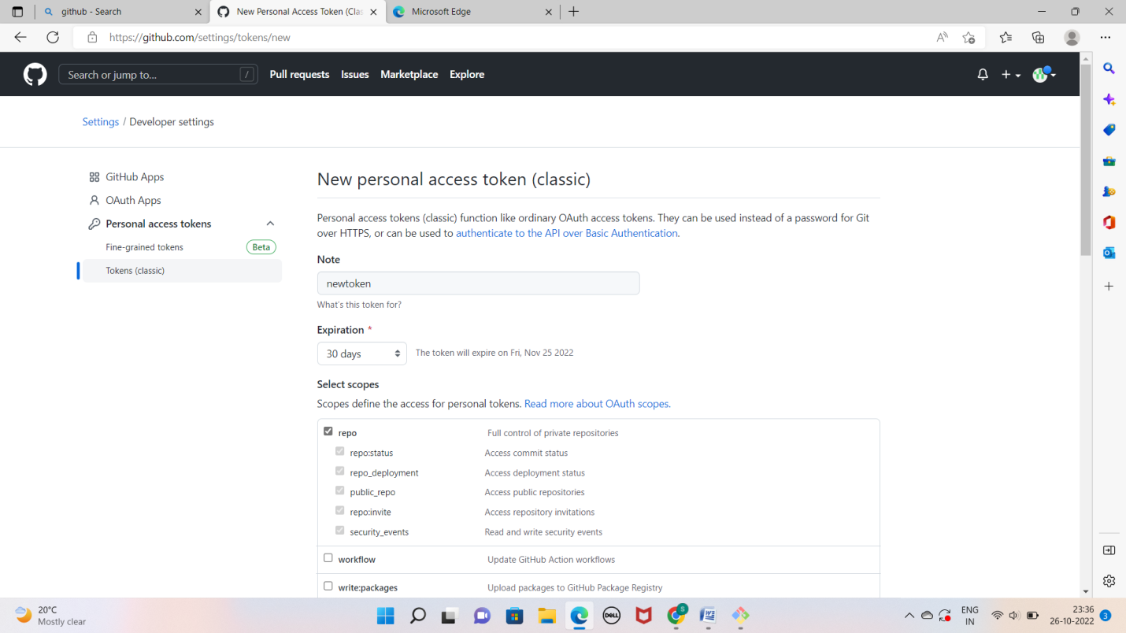

1. click on generate token
2. copy this token and keep it safe
3. 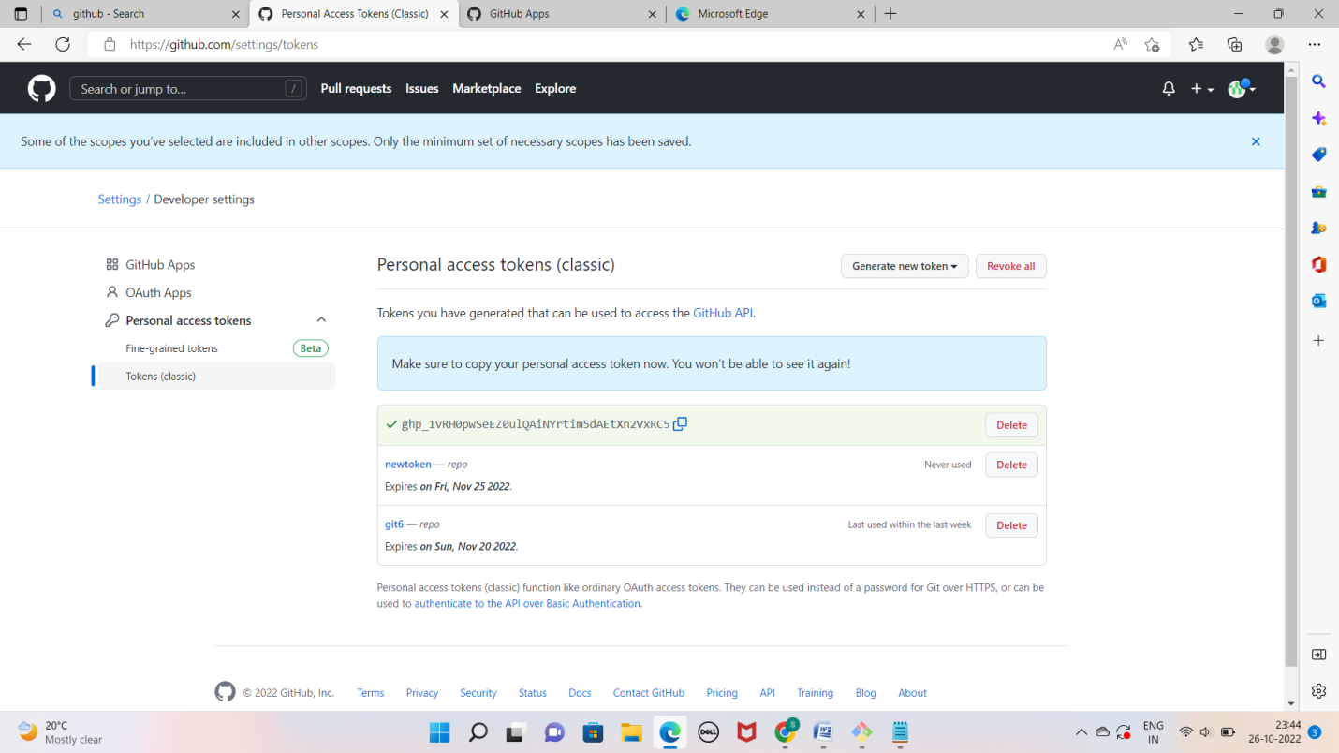

* Clone the repo again in your local machine and this time provide the token in place of password while cloning

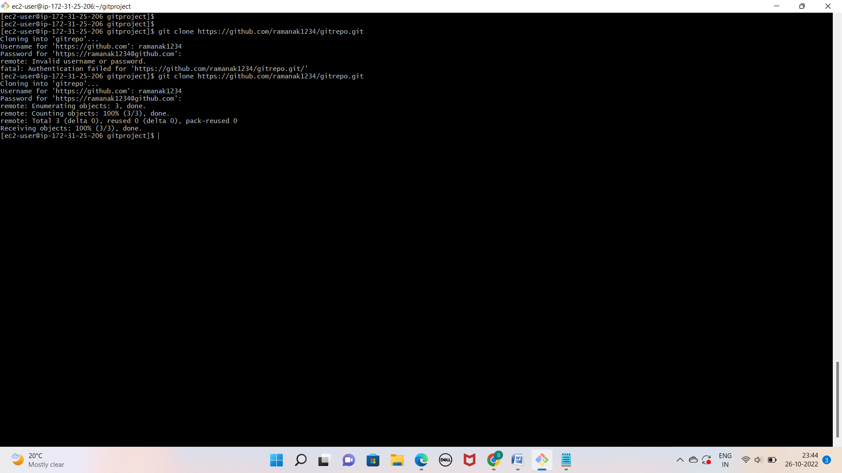

* Once cloned go to the repo folder and add some sample files. We can use touch command to create empty files.

a.touch text1 text2

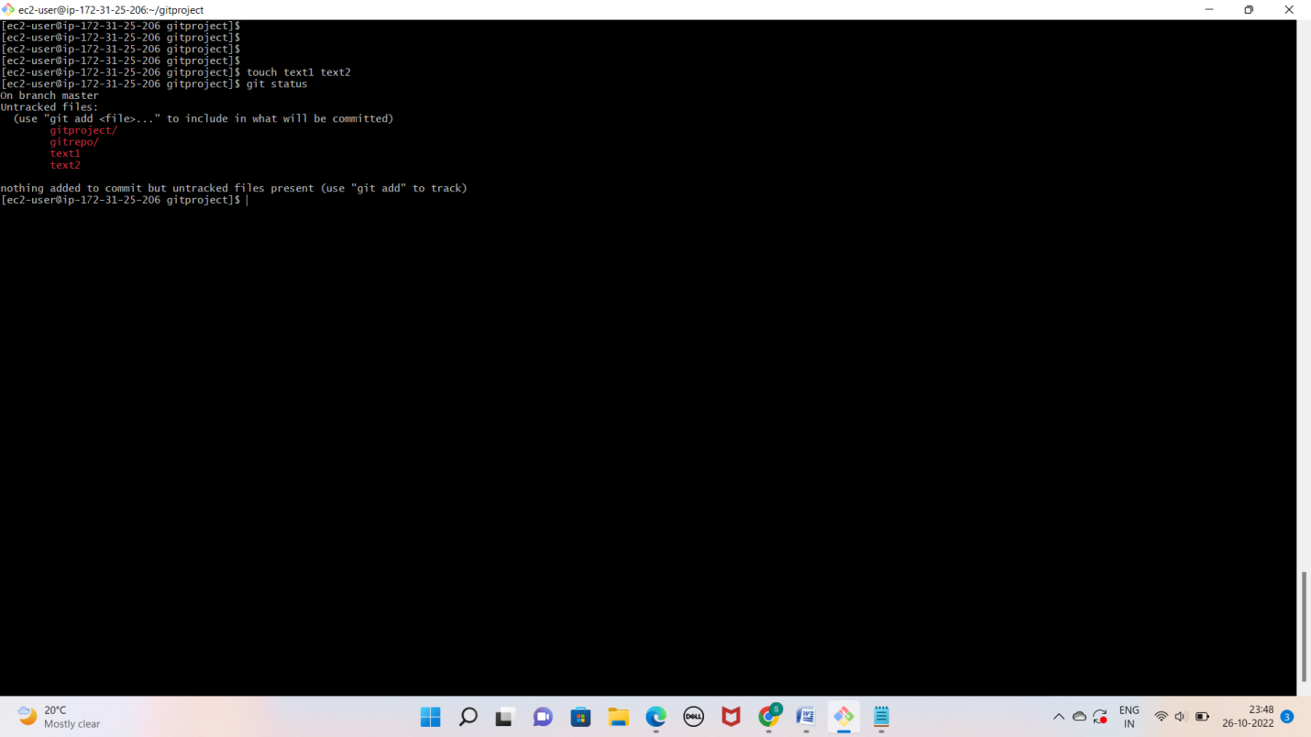

* Stage these changes by running git add text1 text2

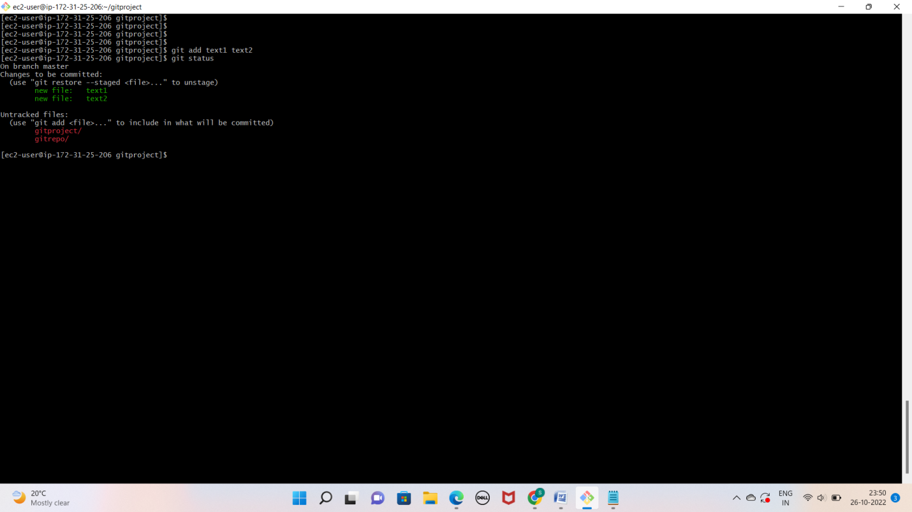

* Commit these changes by running git commit –m

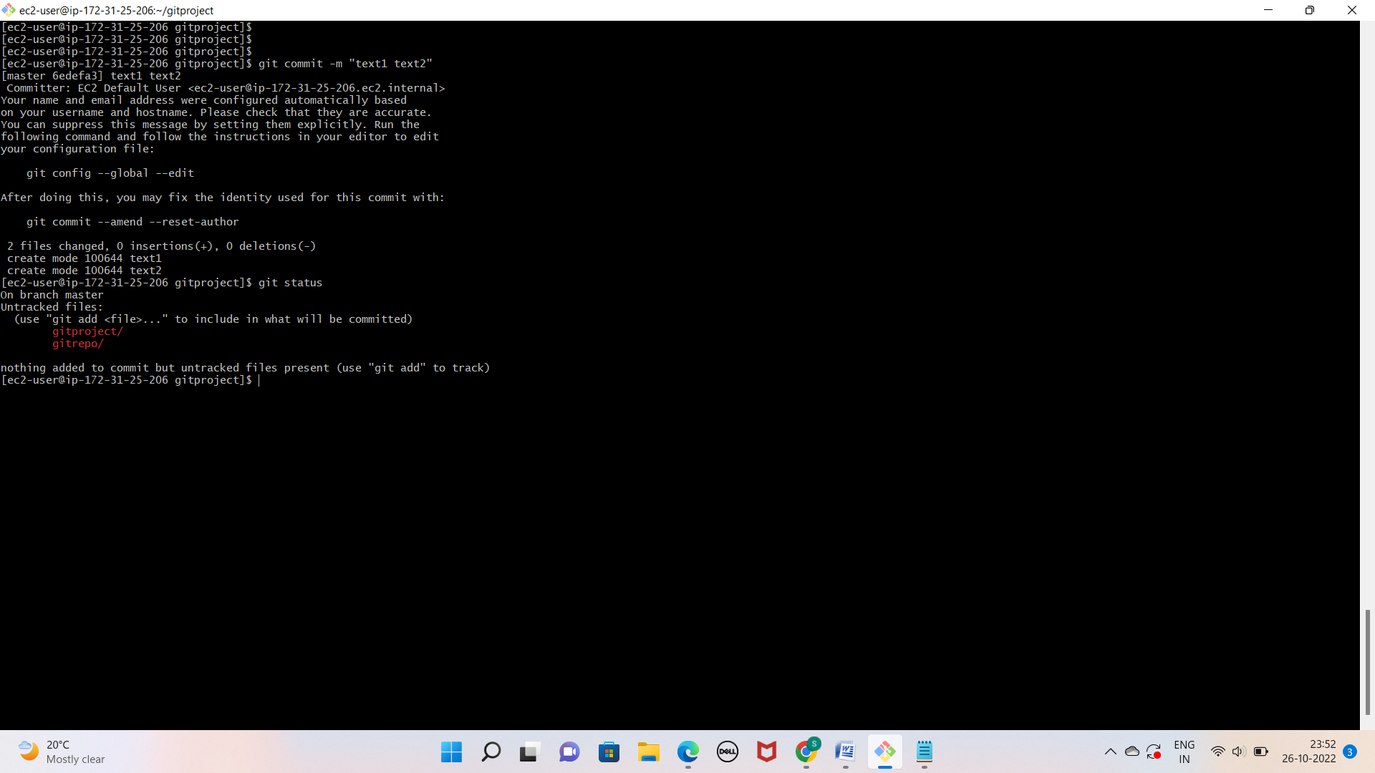

* Git push it will ask you for username and password, provide the username and personal access token in place of password which we crated above.

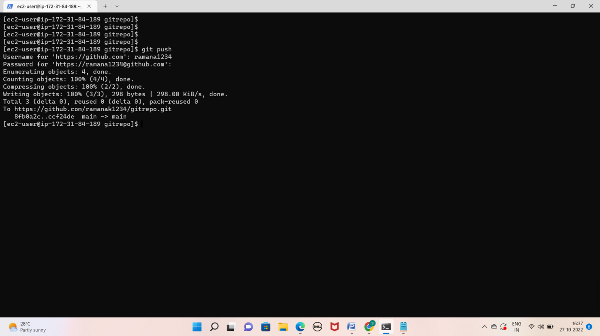

* Go to the remote repo and see, you will be able to find your new changes

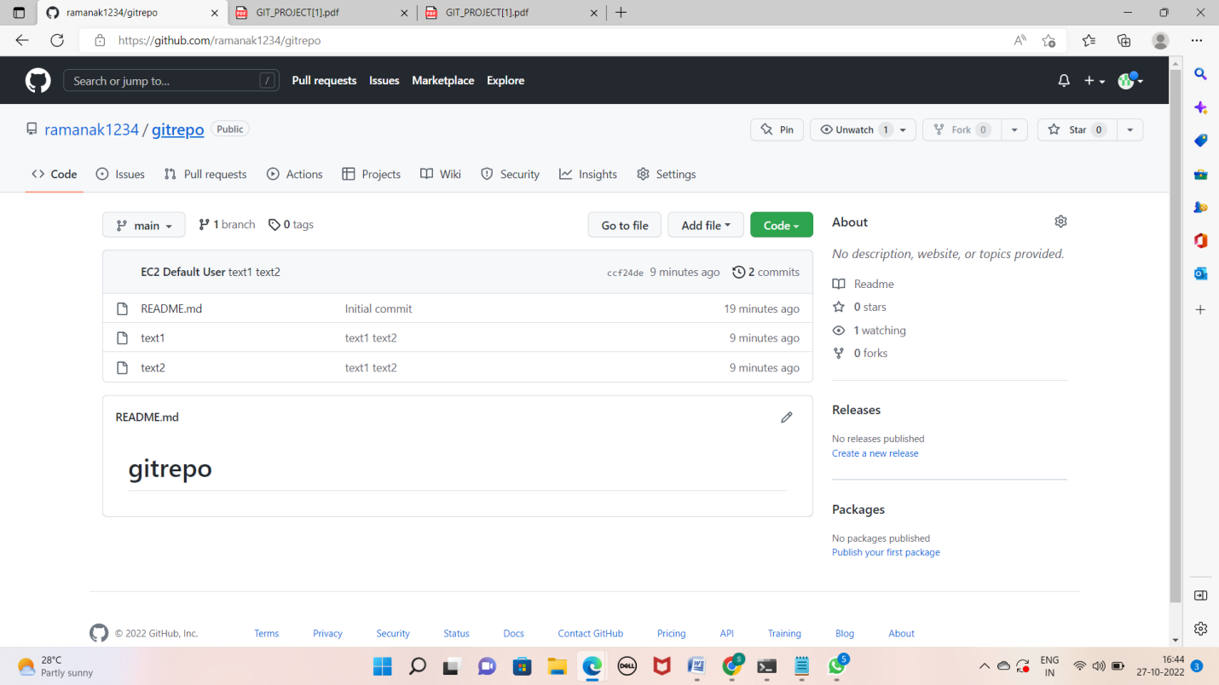

LAB 5: (Pushing a locally created repo to GitHub)

* Create one repo in our local machine and initialize it locally (we have done it in

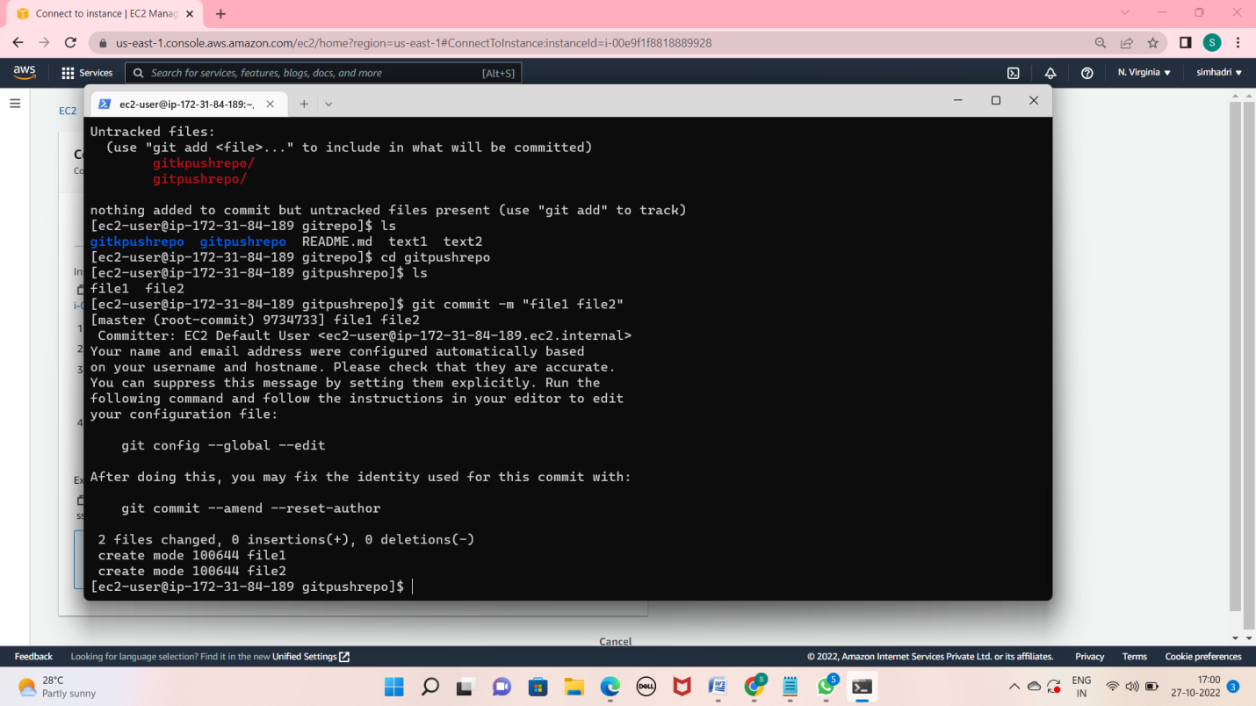

* Create one remote repo with the same name as local repo in GitHub and do not initialize it

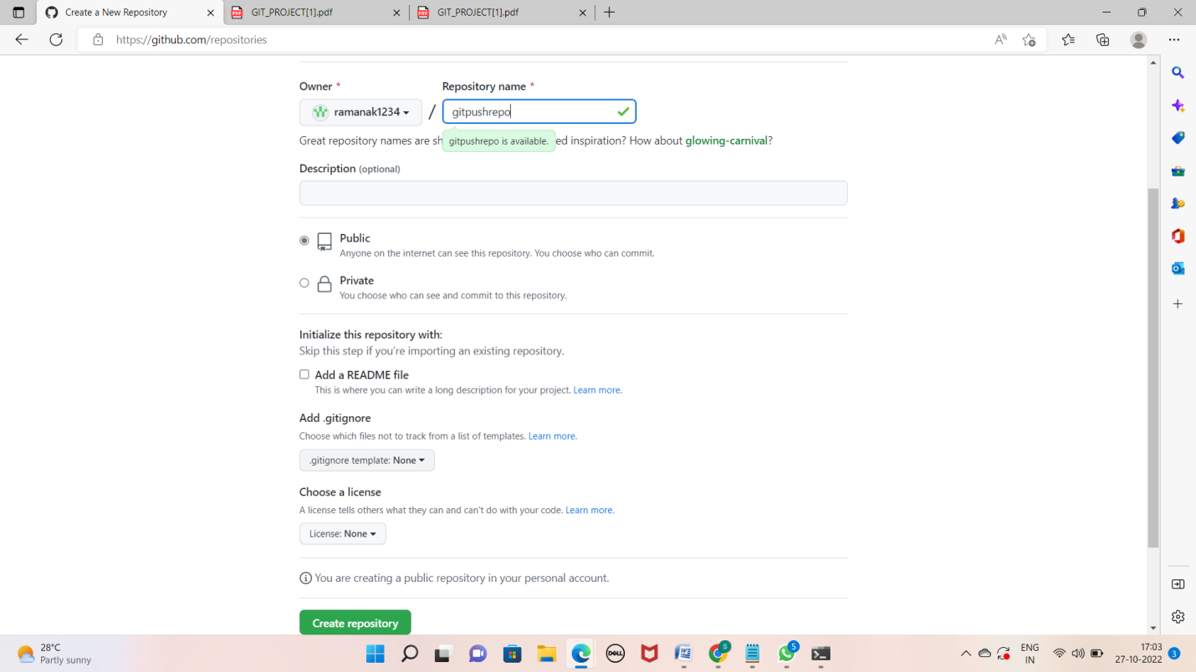

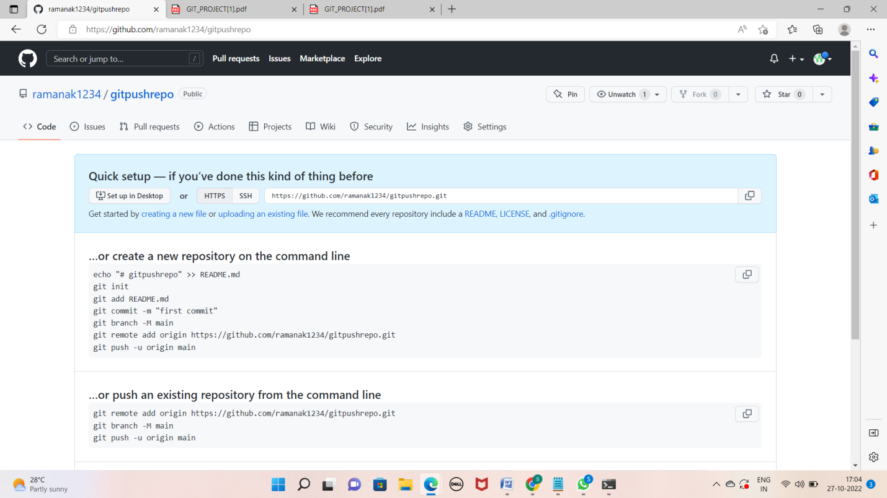

* Come to your local machine and run the following commands from inside your local repo

a. git branch -M main (to change the name of branch as master branch is now known as main branch).

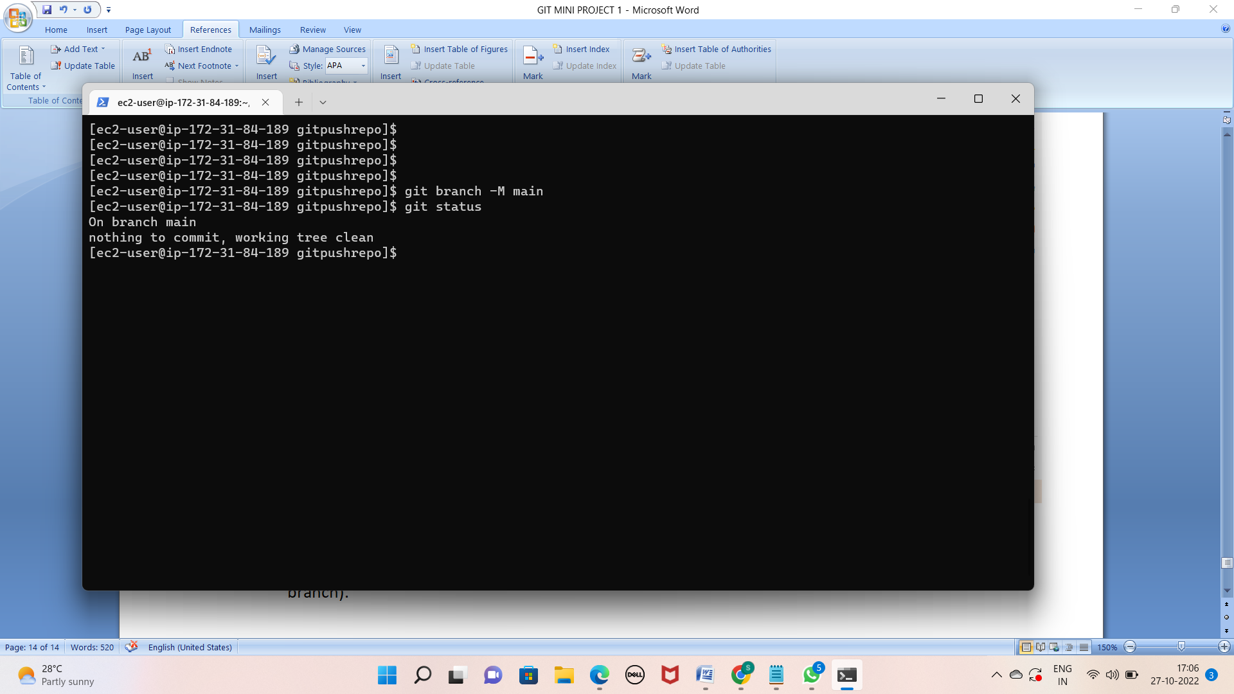

b. git remote add origin

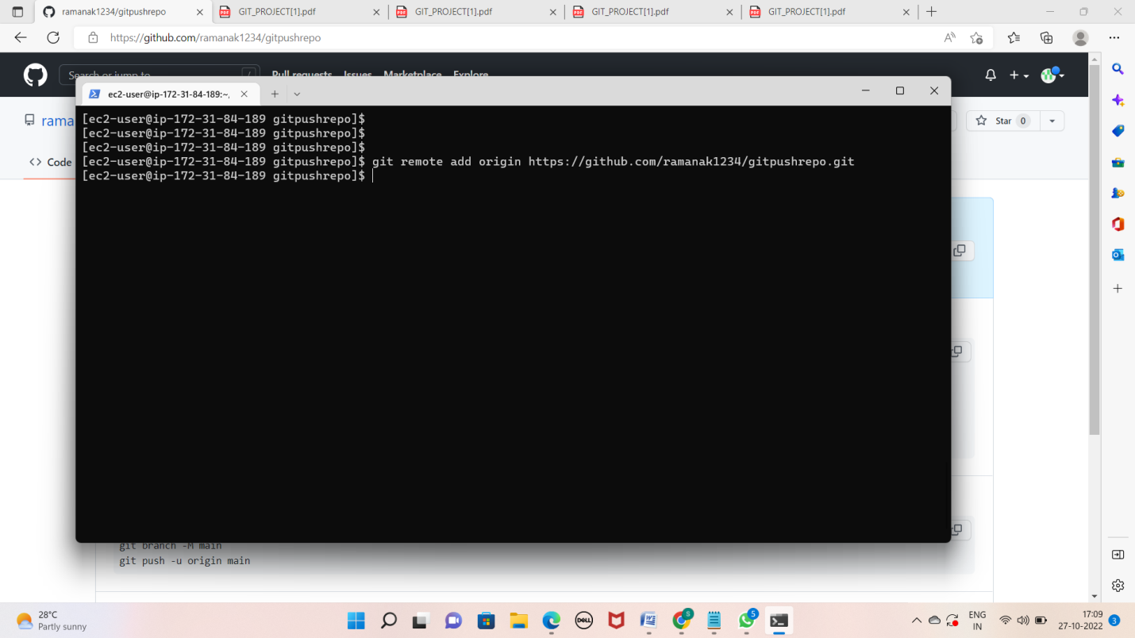

c. git push –u origin main

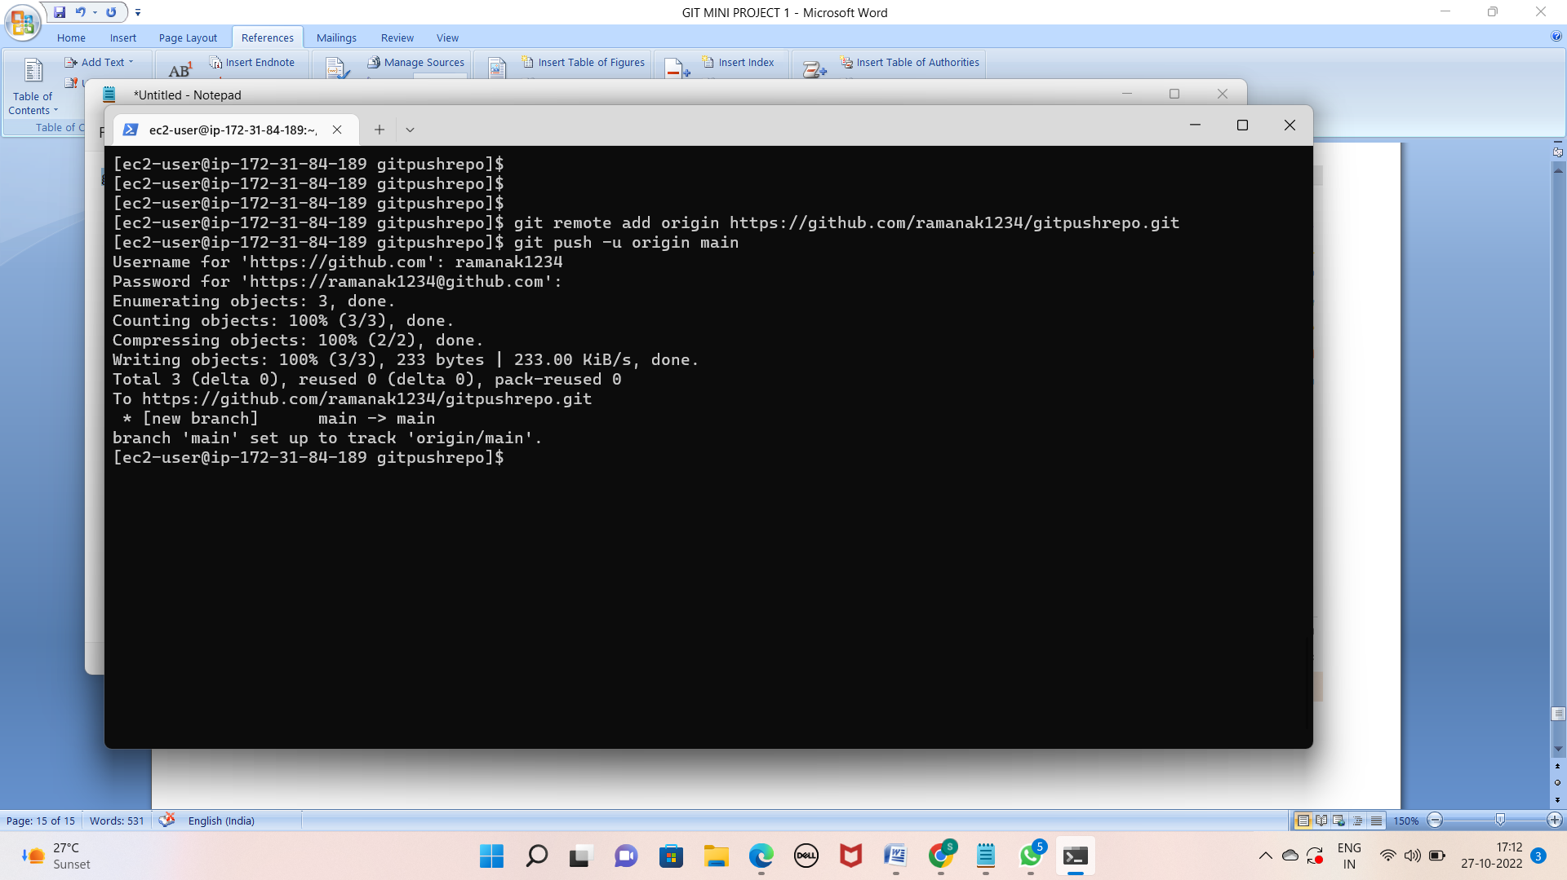

LAB 6: (Creating a new branch from your main branch):

* Go to the repository at the place of main and click on the branch dropdown

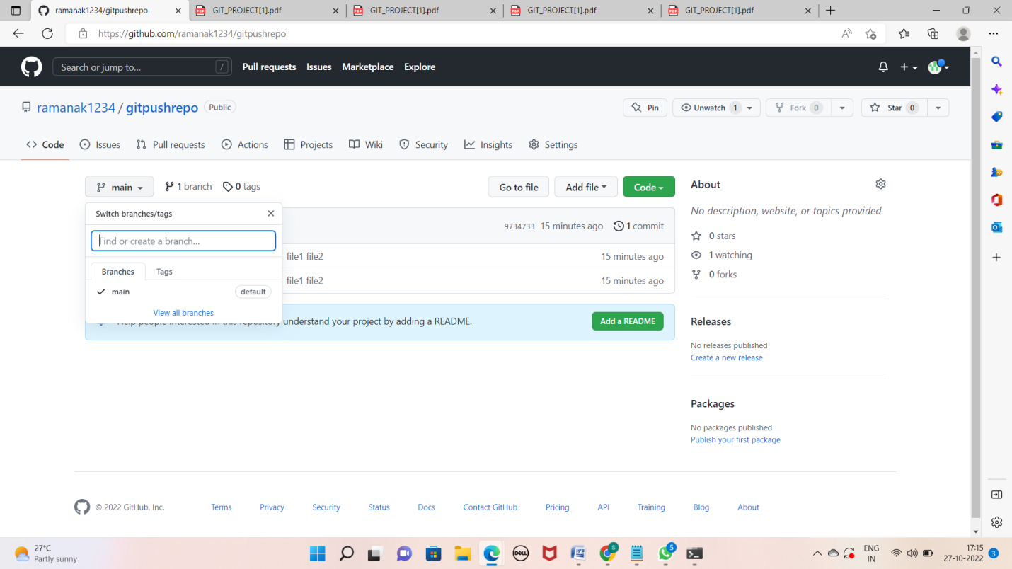

Type the name of your new branch that you want to create and click on create button.

* A new branch will be created for you

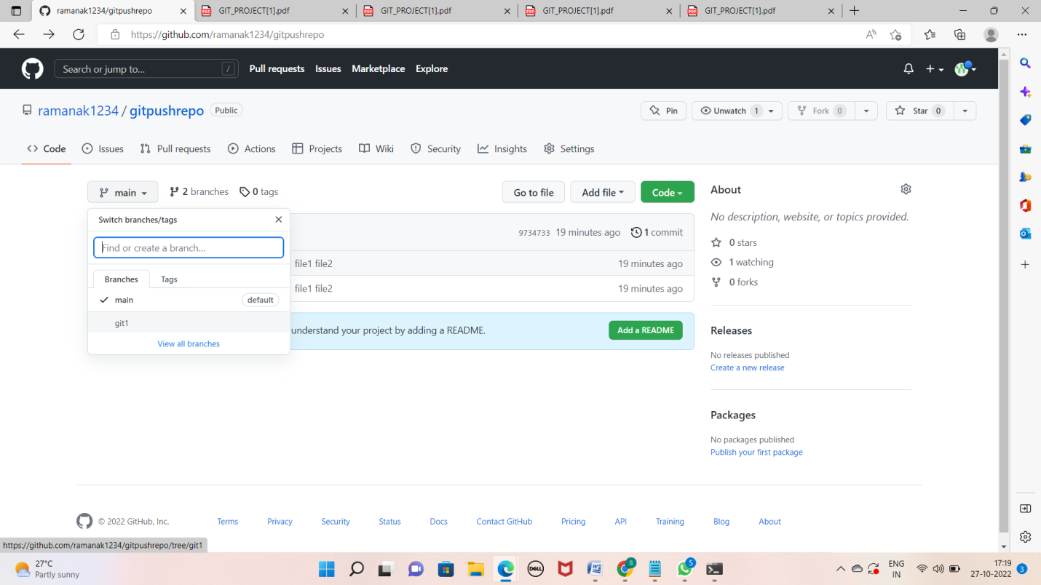

* Make some changes in this branch directly from the console

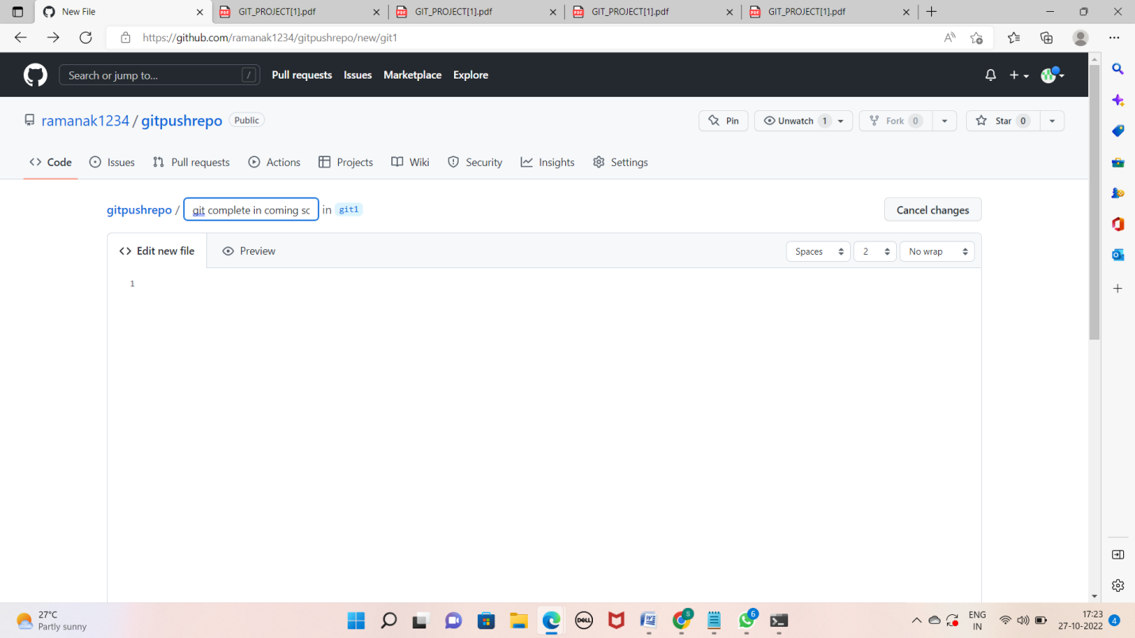

* Here you will see that your changes are only applied to your new branch but not to the main branch

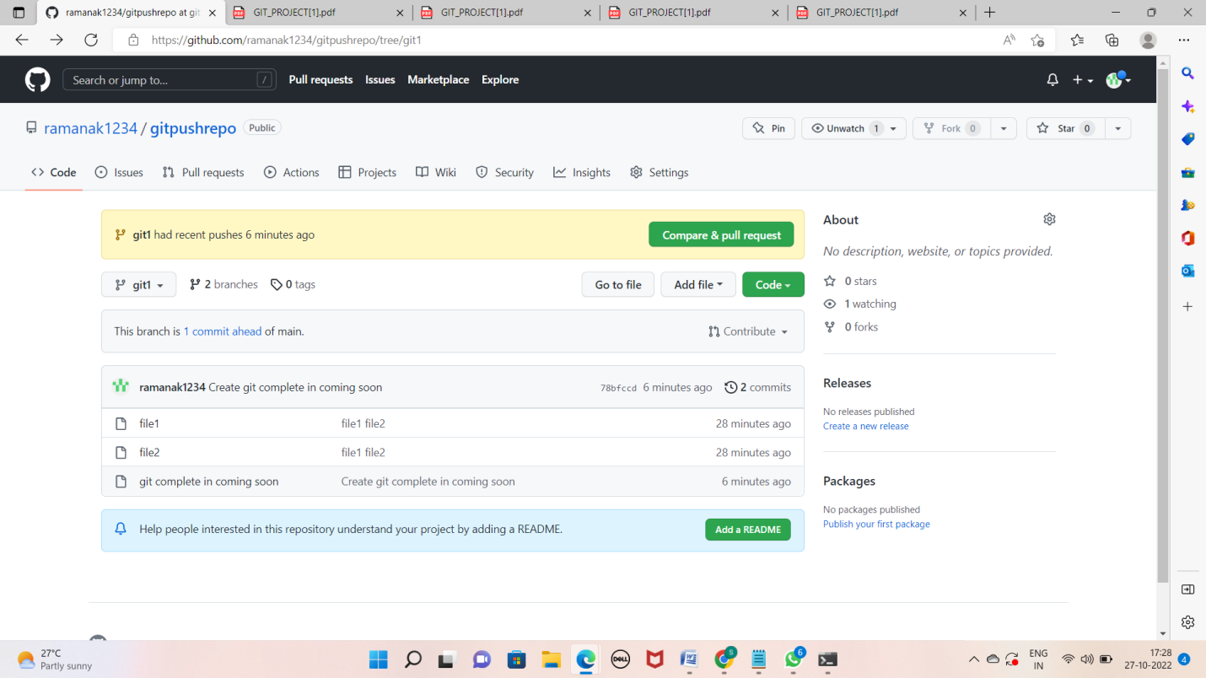

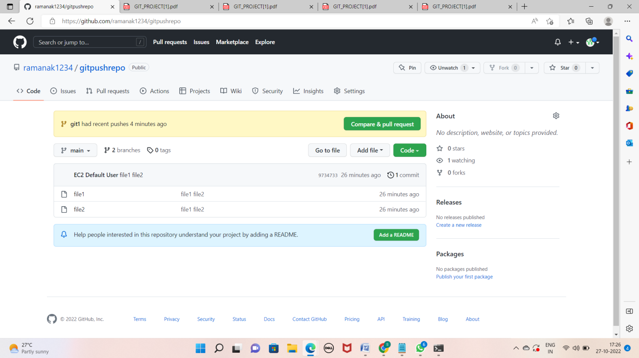

LAB 7: (Pull all the branches in your local machine):

* Go to your local machine where you have the copy of your remote branch

* Run the command "git pull" to pull all the new changes such as branches from the remote location

* Run "git branch -a" to list down all the branches.

a. The branch which starts with remotes/ ---> are remote branches

Run "git branch -a" to list down all the branches. a. The branch which starts with remotes/ ---> are remote branches

b. The branch without remotes/ ---> they are available on your local copy as well

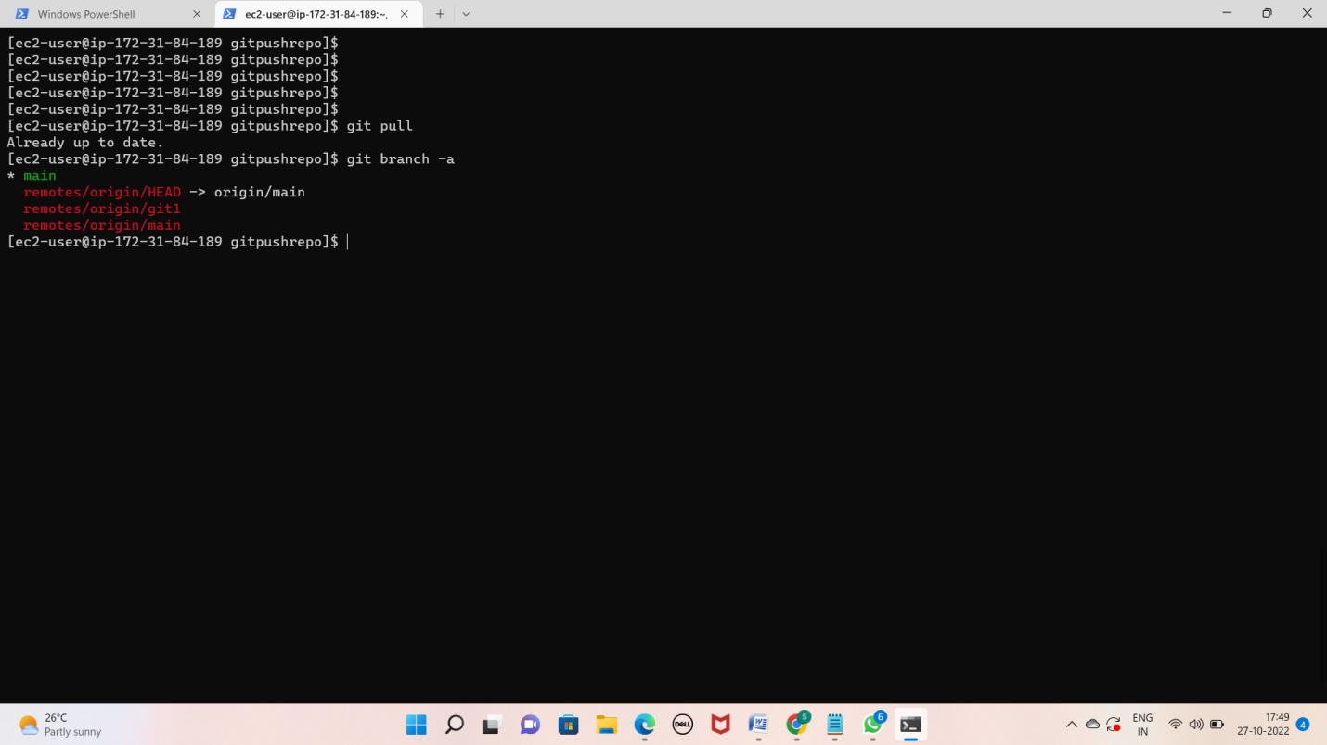

Checkout to the feature branch or the branch that you created

a. git checkout

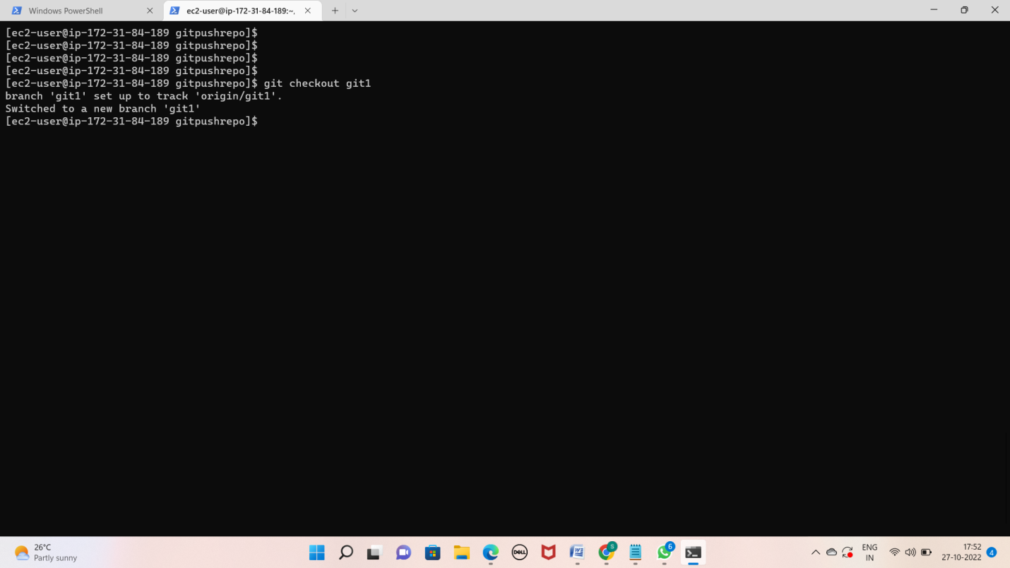

* Make sure that you are on the new branch by running git status or git branch command

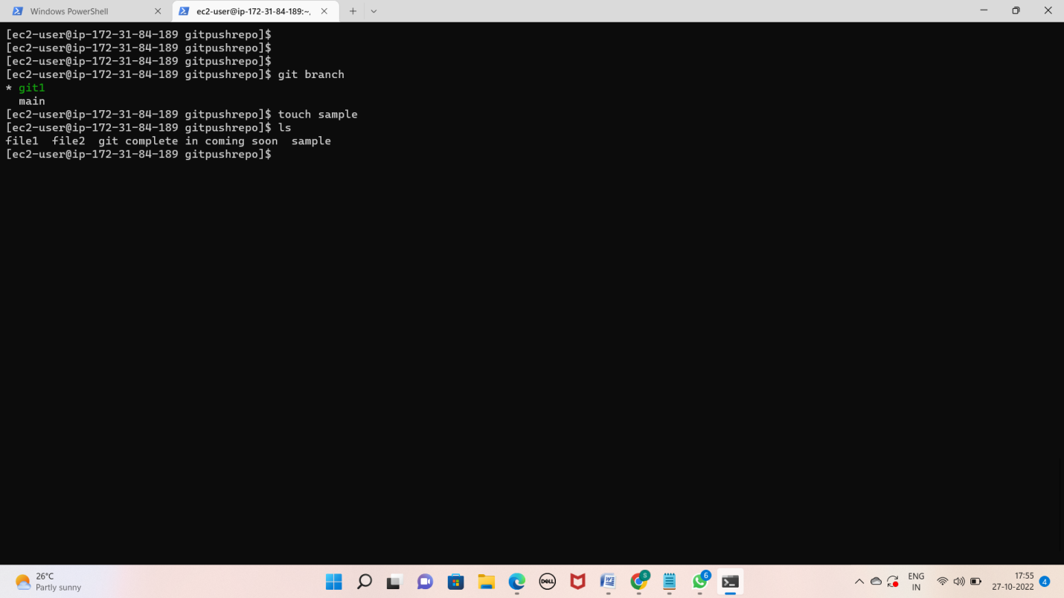

Make some changes in this branch such as adding the files "touch sample"

* git status
* Git add

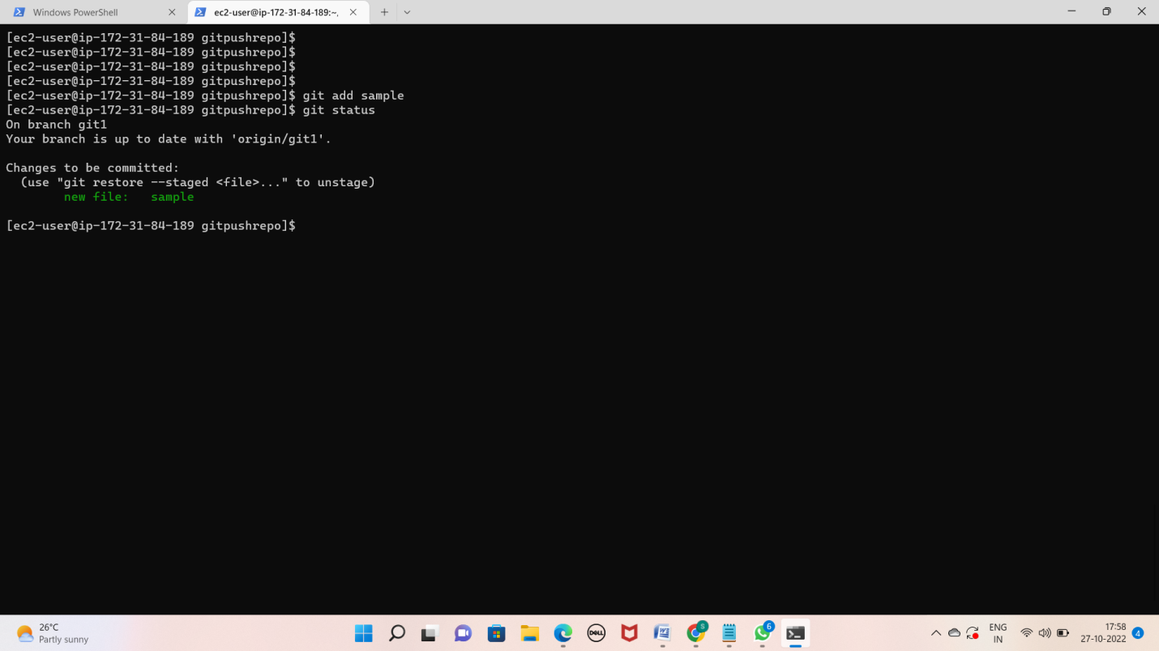

* Git commit –m “”

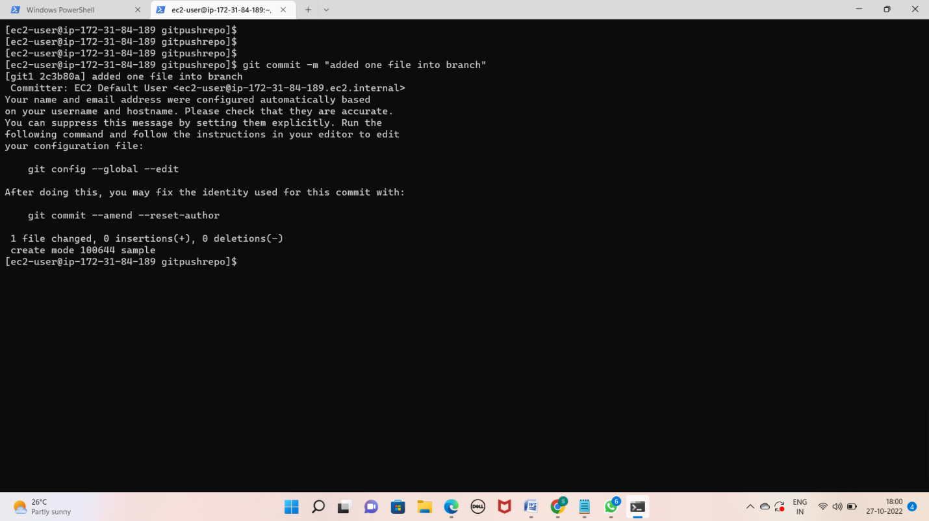

* Git push

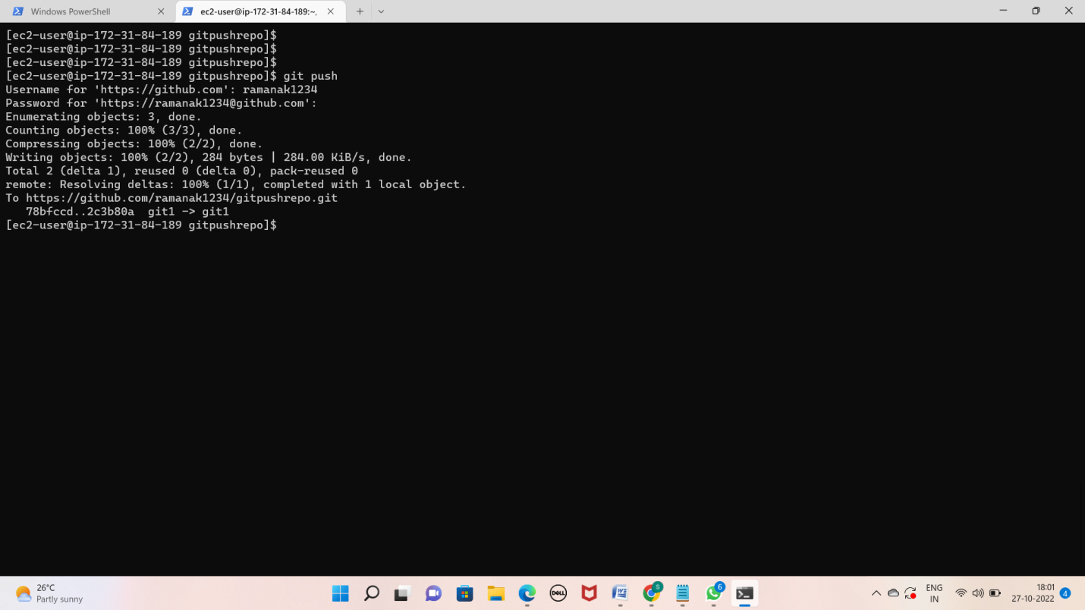

* Go to your GitHub portal once again
* Here see that the new changes are only available in your feature branch but not in the main branch

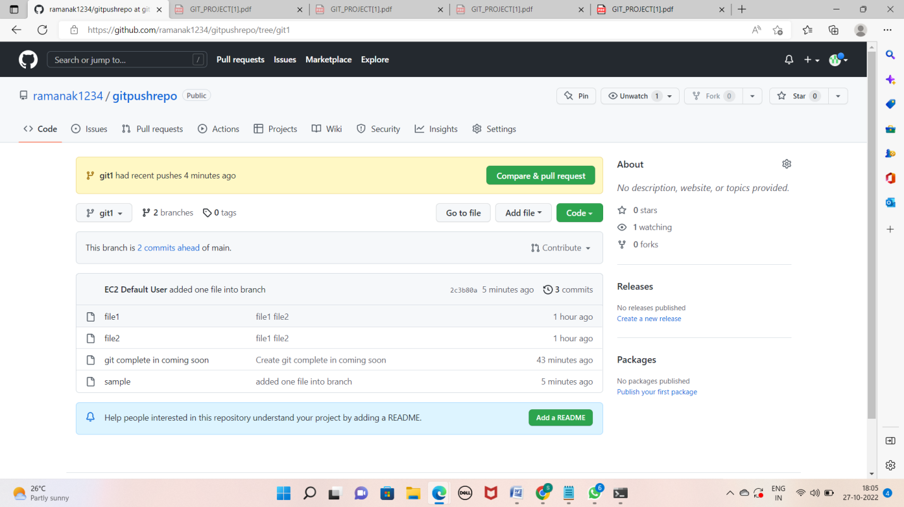

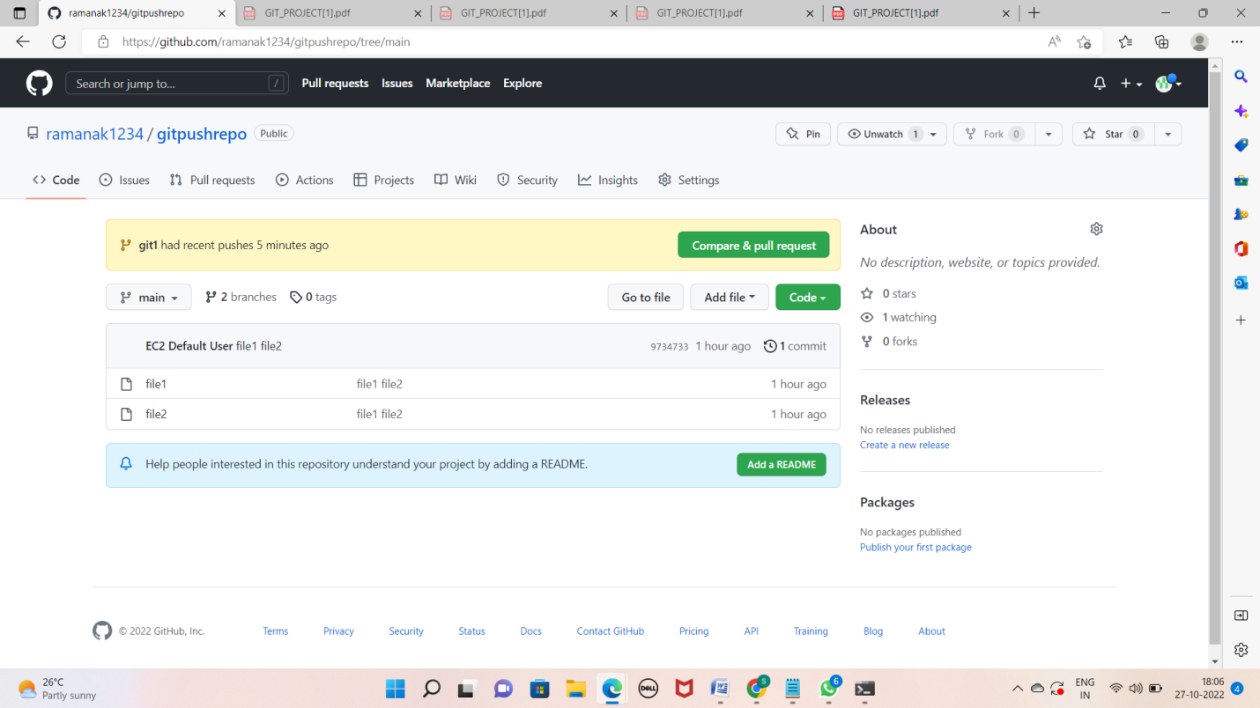

Lab 8: (Merge our feature branch with main branch)

* Go to your GitHub repository
* Check the changes in your feature branch

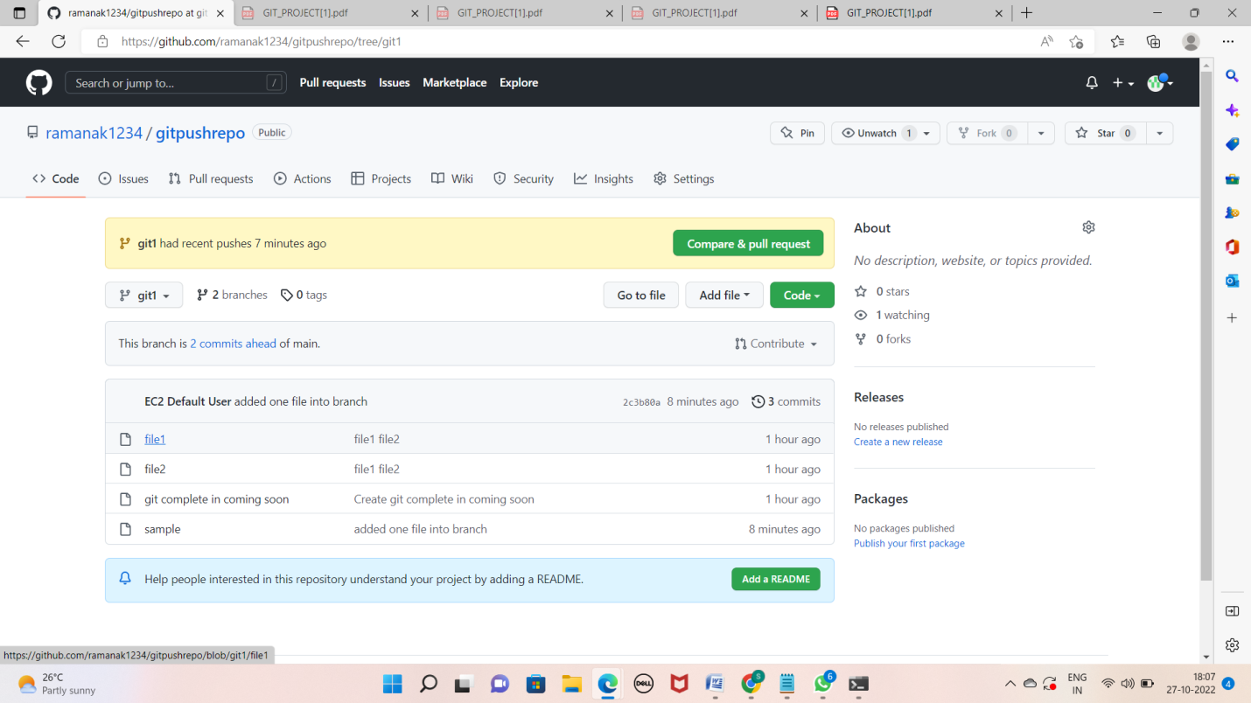

* Go to the pull request tab and click on create pull request

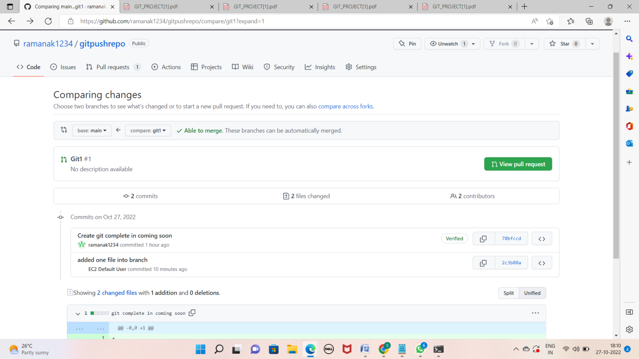

* Put your main branch (where u want to merge / destination) and the feature branch in the respective blocks

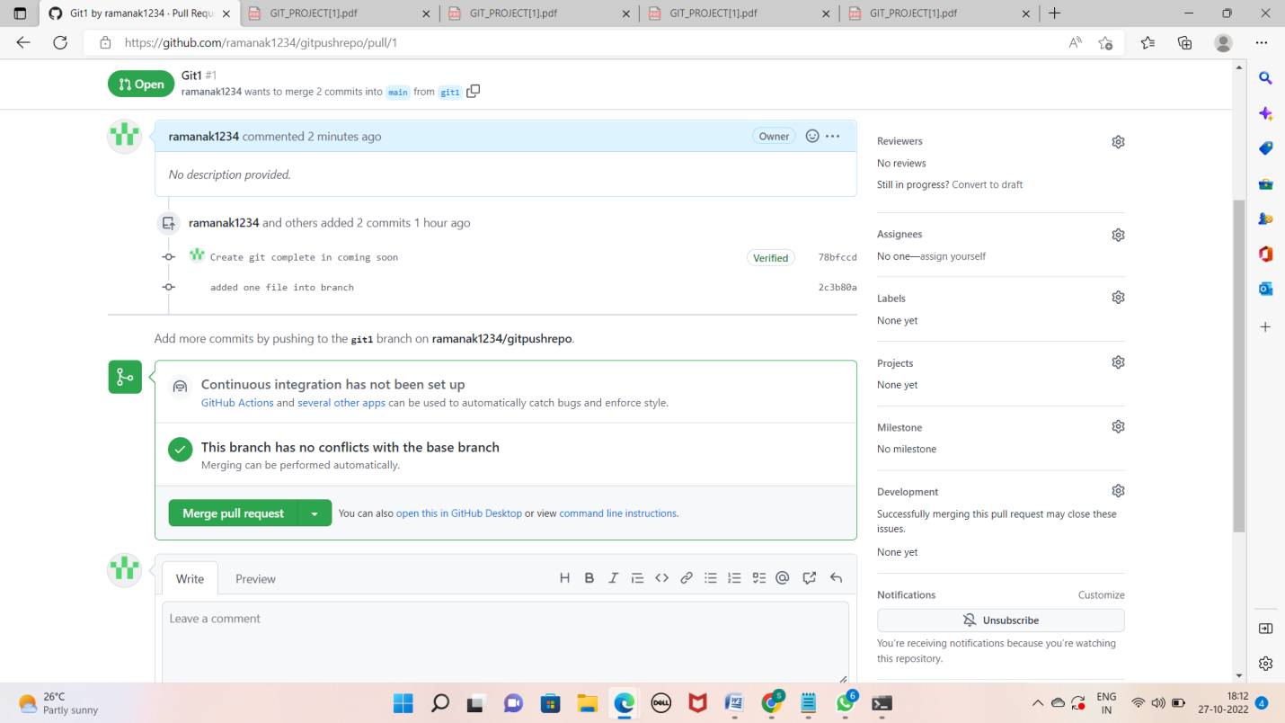

* Click on review changes and then merge

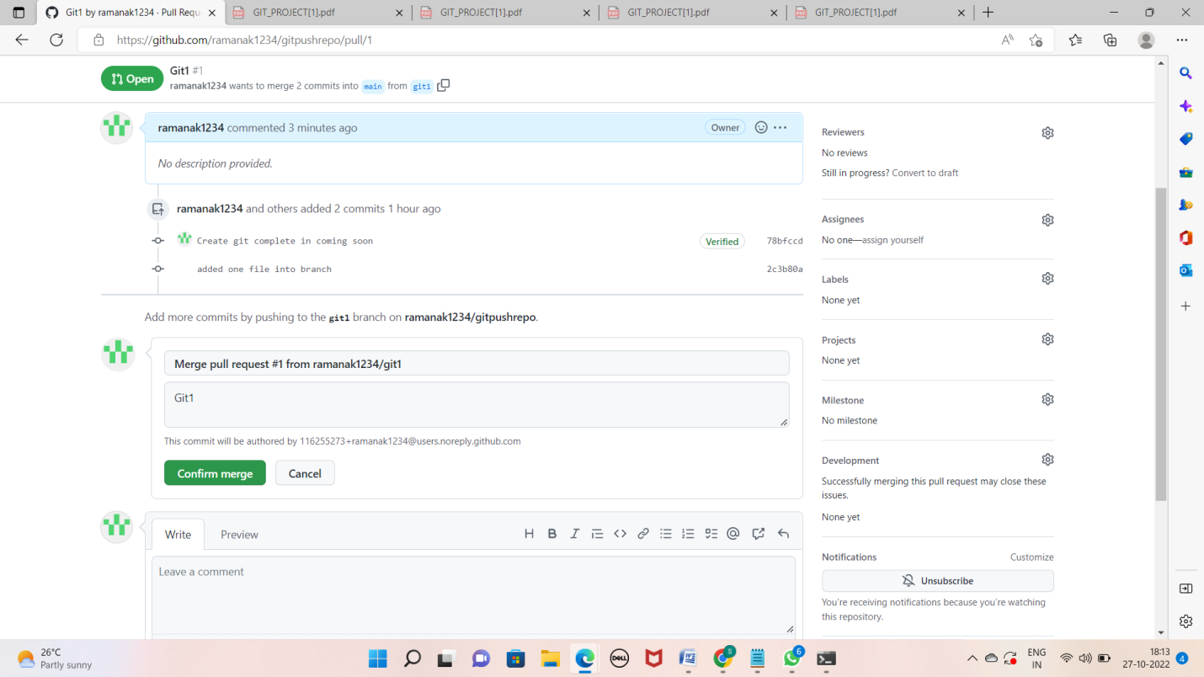

* Once done, you can delete this feature branch if required or you can simply ignore it

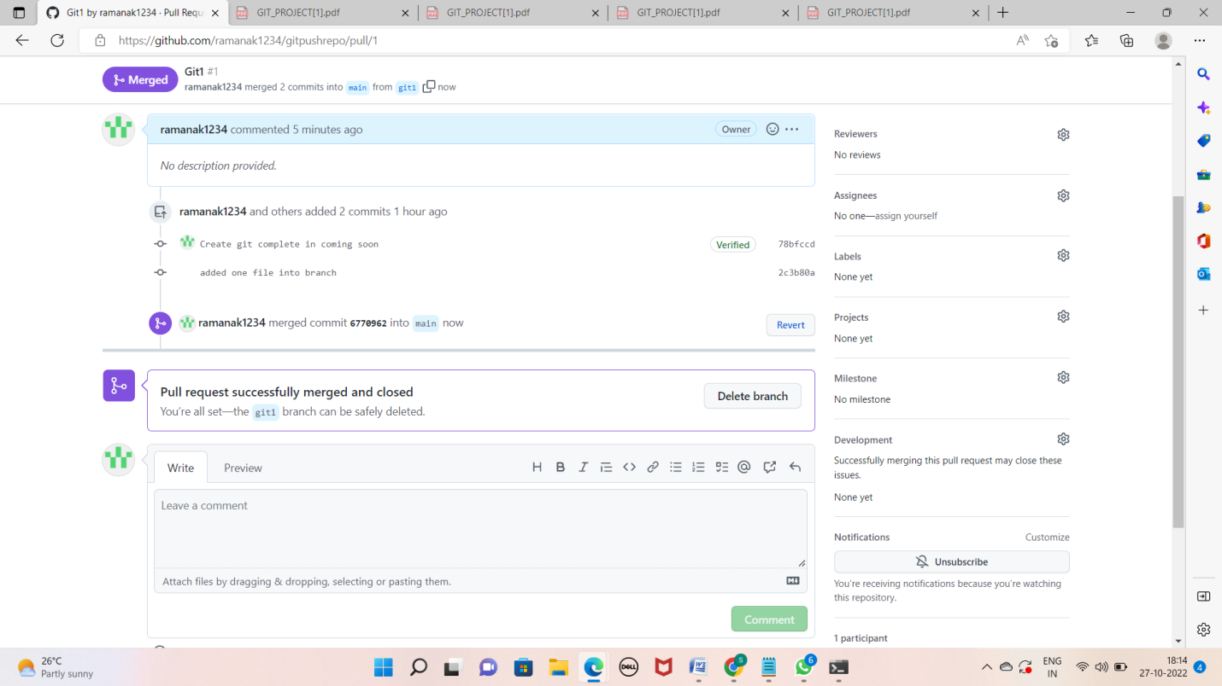

* Go to your code in main branch and see the changes are now visible here

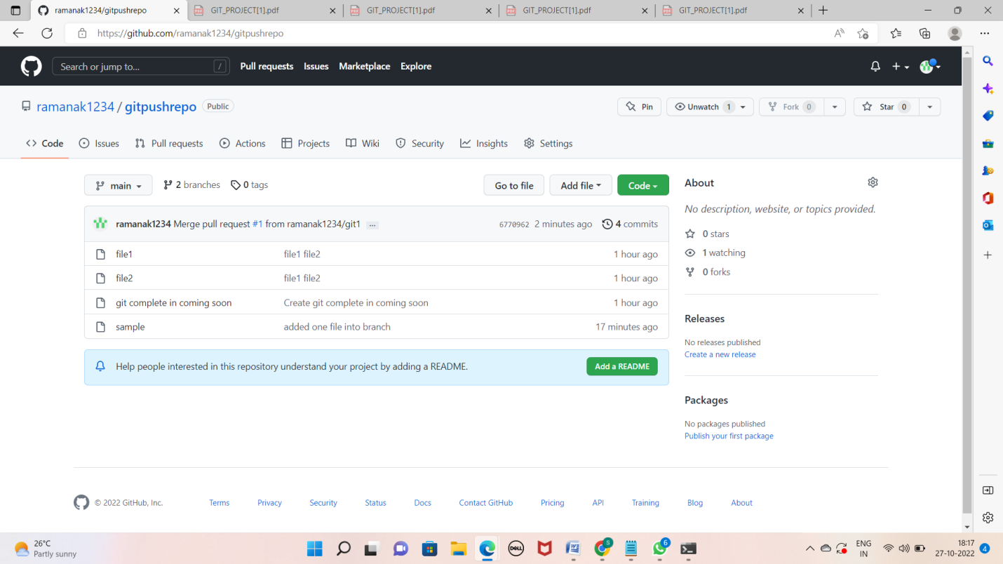

Lab 9: (Go to local machine)

* Go to your local machine where you have the copy of your remote repo

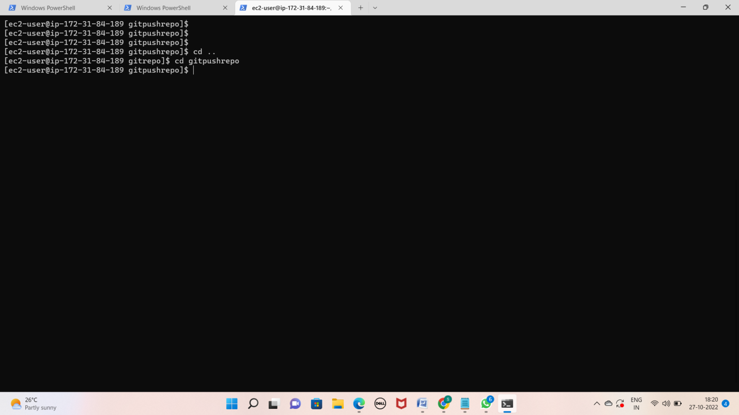

Checkout to the main branch

a. git checkout

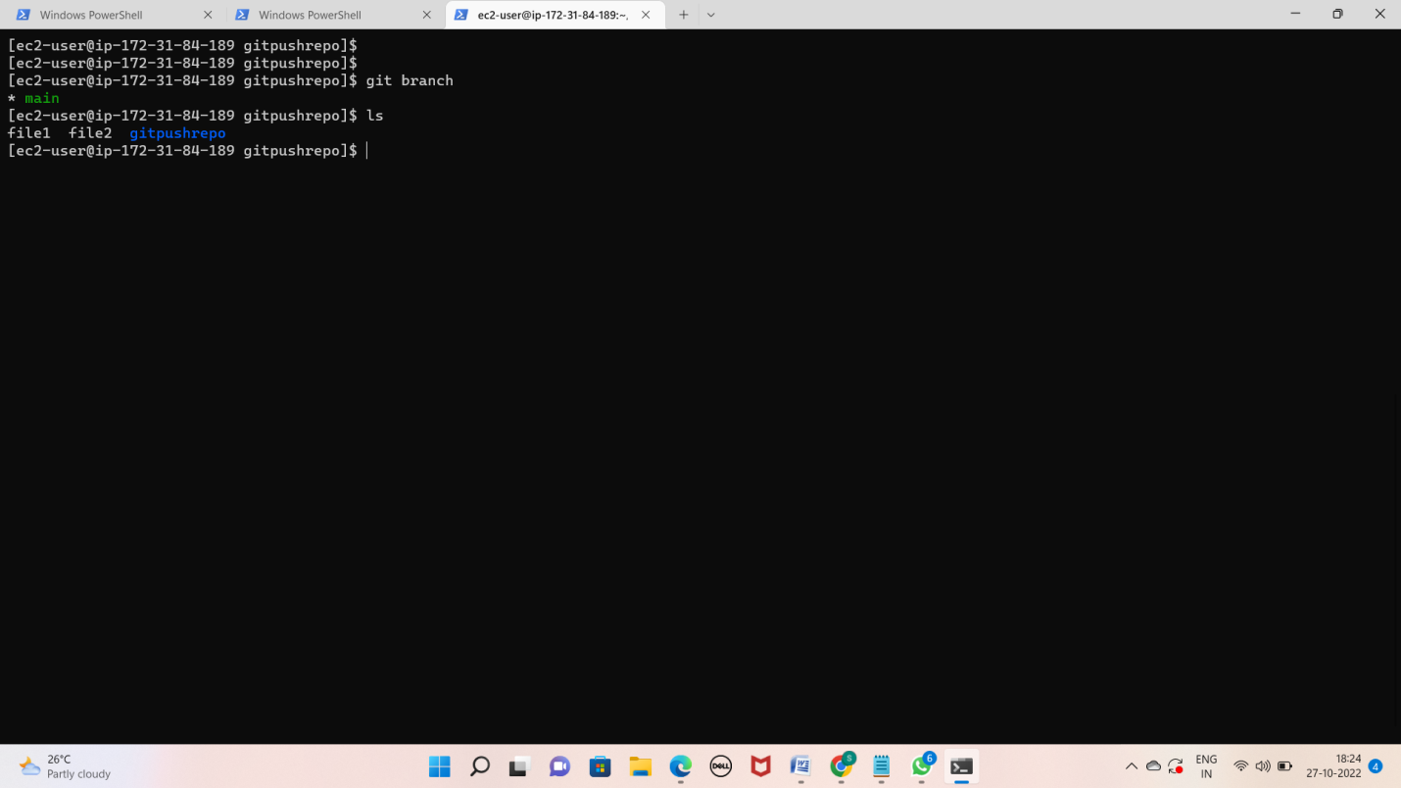

Now run the command "git pull" to pull all the new changes such as branches from the remote location

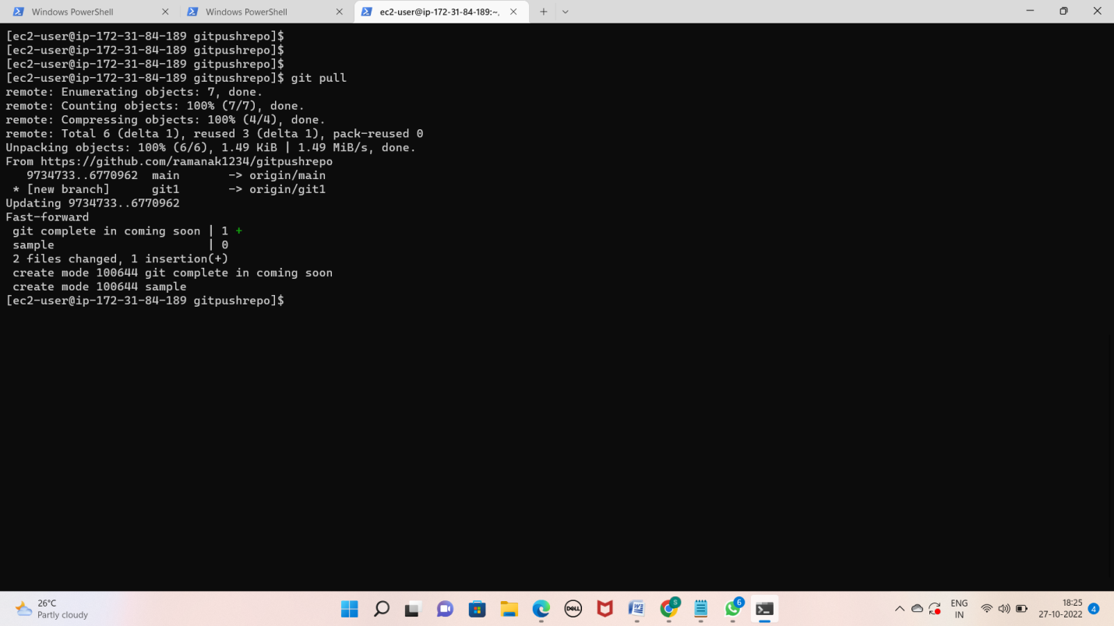

*Here see that the new changes are only available in your main branch

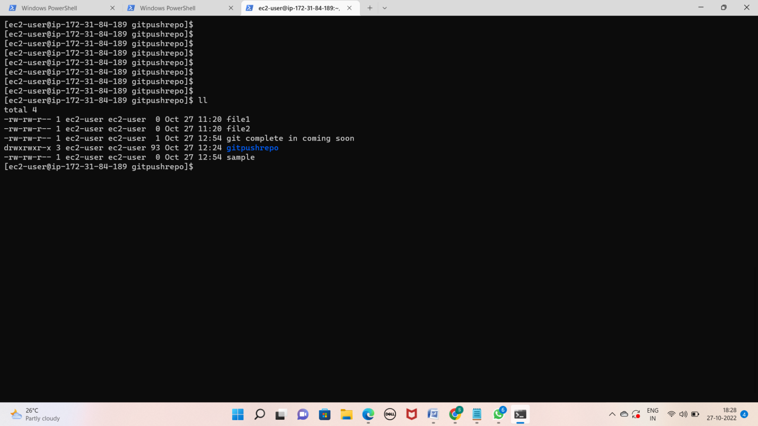

Thank you

K. ramana